CREATING SHARED STORY:

STORY OF US

Who is this community and what are we called to do?

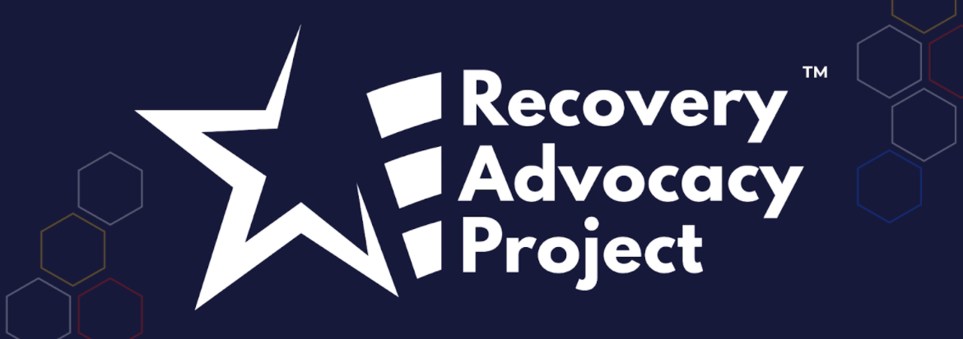
ORGANIZING INSTITUTE
ACKNOWLEDGEMENTS

We welcome your suggestions for improving this guide further for future trainings. We also welcome you to use it and adapt it for your own trainings, subject to the restrictions below.
This workshop guide has been developed over the course of many trainings by Liz Pallatto, Joy Cushman, Jake Waxman, Devon Anderson, Rachel Anderson, Adam Yalowitz, Kate Hilton, Lenore Palladino, New Organizing Institute staff, MoveOn Organizers, Center for Community Change staff, Jose Luis Morantes, Carlos Saavedra, Sean Thomas-Breitfeld, Shuya Ohno, Petra Falcon, Michele Rudy, Hope Wood, Josh Daneshforooz, Melanie Vant, Uyen Doan, Abel R. Cano, Voop de Vulpillieres and many others.

RESTRICTIONS OF USE

The following work [this workshop guide] is provided to you pursuant to the following terms and conditions. Your acceptance of the work constitutes your acceptance of these terms:
- You may reproduce and distribute the work to others for free, but you may not sell the work to others.
- You may not remove the legends from the work that provide attribution as to source (i.e., “originally adapted from the works of Marshall Ganz of Harvard University”).
- You may modify the work, provided that the attribution legends remain on the work, and provided further that you send any significant modifications or updates to marshall_ganz@harvard.edu or Marshall Ganz, Hauser Center, Harvard Kennedy School, 79 JFK Street, Cambridge, MA 02138
- You hereby grant an irrevocable, royalty-free license to Marshall Ganz and New Organizing Institute, and their successors, heirs, licensees and assigns, to reproduce, distribute and modify the work as modified by you.
- You shall include a copy of these restrictions with all copies of the work that you distribute and you shall inform everyone to whom you distribute the work that they are subject to the restrictions and obligations set forth herein.

If you have any questions about these terms, please contact marshall_ganz@harvard.edu or Marshall Ganz, Hauser Center, Harvard Kennedy School, 79 JFK Street, Cambridge, MA 02138.

INTRODUCTION TO STORY OF US

Goals for this session:
- To learn how to tell the story of our community in a way that reflects our shared values, hopes, and experiences
- Each participant practices telling a Story of Us and gets feedback on their story

What is a Story of Us?
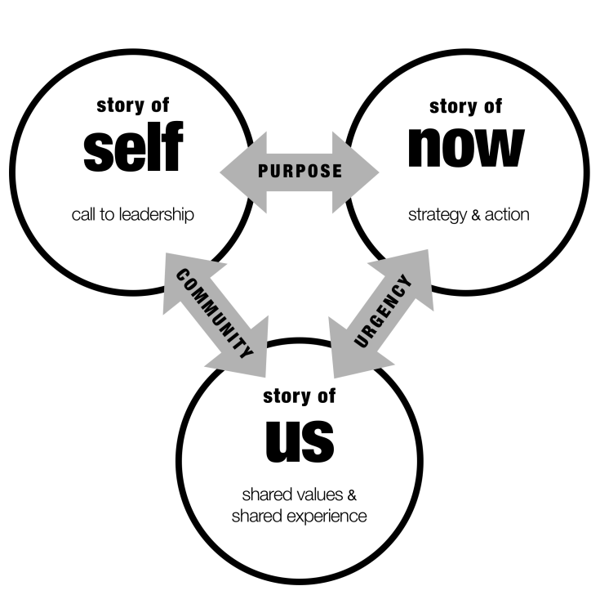
You tell a story of self to enable others to “get you” – to experience the values that call you to public life. You tell a “story of us” to enable them to “get each other”- to experience the values they share that can inspire them to act together, find courage in each other, and find hope in their solidarity. In other words, the “us” that the storyteller brings alive is based less on what “category” describes them (race, gender, language, etc.), a “categorical us”, than values the share rooted in common experience, an “experiential us.” By learning to tell a story of us you can bring those values alive as a source of solidarity, hope, and the motivation to act.

Crafting a Story of Us.
One way people develop their sense of “usness” is by sharing stories that celebrate values they share. They may share stories of family, community, faith tradition, school life, profession, movements, organizational happenings, national experience, generational moments, cultural events, or even global occurrences. But, as stories, they’re about our experience of these moments, challenges we faced, obstacles we overcame, or didn’t, values we tested, or that tested us, and lessons we learned that made us who we are.

The character in the story of us is the people you are motivating to act.
Our story of self is interwoven with stories we share with others through communities we are a part of, which have stories of their own. These include stories of our family, community, faith tradition, school, profession, movements, organizations, nations and, perhaps world. It is through shared stories that we establish the identities and express the values of the communities in which we participate (family, faith, nation) and of new communities we are forming (new social movements, new organizations, new neighborhoods).
Telling a "story of us" requires learning how to put into narrative form experiences the “us” in the room share, that “lift up” the values on which you will be challenging them to act. This story of us may well reach beyond the people in the room, drawing in a wider range of experience, and larger stories of us, but to be effective it must be rooted in the experience of the people in the room.

The Story of Us in the Room
Although the reach of a story of us may extend far beyond “people in the room” it becomes real only in the experience of the “people in the room” – or not. The test is simple. As we heard this story did we begin to feel like an us? The experience of shared values may grow out of stories of historic moments we remember, or have heard of; they might be stories of life events like having children, stories of finding out you were accepted to this program; stories of what happened the first time you met, or last night, or this morning. And, like all stories, the more detailed, the more specific, and he more visual they are, the more effective they will be. What were the names of the people involved? What did they look like? How were they different? Sometimes stories of us emphasize obvious differences in race, religion, gender, age, for example, may actually highlight commonality of values or common purpose.

Linking Story of Self and Story of Us
A story of self tells people who you are and why you are called to do the work that you are doing. The goal is for them to “get you”, to connect with you. Since organizing is about building power with others for shared action, your public narrative also needs to tell a story of the values shared by those whom you hope to move to collective action. The test of a story of us is whether or not they “get” their connection with each other.

Narrative Structure: Challenge, Choice, Outcome

Remember the story structure we introduced in telling your Story of Self?
Just like in your Story of Self, your Story of Us has a clear challenge, choice and outcome:
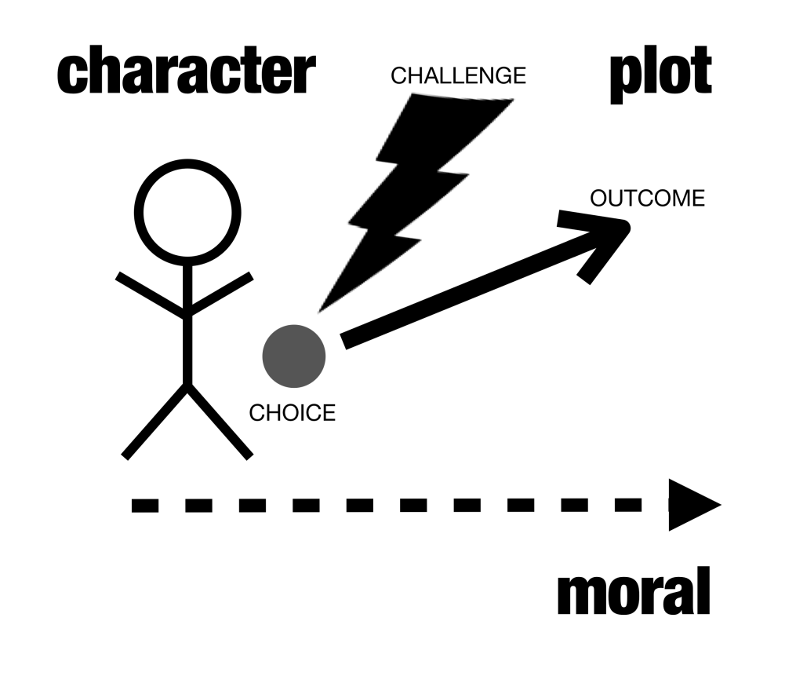
The Challenge: The challenges your community has faced in the past and done something about (made real with stories, images, and details, not statistics).
The Choice: For a story to be a story, it centers on a “choice”. In a story of us, that choice is one that met challenge with action, and thus can be a source of hope. Founding stories recount choices made by those who initiated the community, enabling us to experience the values that motivated them. Choices made by people in the course of the workshop – to take risks, to be open to learning, etc. – can become part of the ‘story of us” of the workshop.
The Outcome (hope): Stories with vivid images that remind your community of what you’ve achieved. Your own experiences of hope, experiences that point to your future.

Stories of us can begin to shift power relationships by building new community and new capacity

Often after we’ve heard others’ stories of self and we’ve started building relationships together we discover that we face similar challenges that are rooted in very deep systems of power inequality. Learning to tell stories of Us is a way to begin to join our stories together and acknowledge those shared challenges and the roots of the problem as a community. However a good story of us doesn’t just convey the root of our challenges, but also lifts up our heroes, and stories of even small successes. Those stories give us hope that if we come together and take action as a community we can uproot some of the underlying causes of our suffering.

VIDEO REVIEW:
SUSAN CHRISTOPHER
We'll be watching 3 minutes of Susan Christopher’s Story of Us. As you watch it, focus on the elements of the Story of Us that you hear in her story.
CHALLENGE | CHOICE | OUTCOME
Who is the “us” to whom she appeals? How does she articulate the group’s challenge? What images does she create? | What moments of choice does she recall? What are the values? | Where does she locate the source of hope? What is the outcome of the community’s choices?

- Why does Susan Christopher begin as she does?

- What are the three choices she describes through her story?

- What details, images, moments help bring her story alive?

- What values does her story communicate?

TEAM BREAKOUT SESSION:

STORY OF US PRACTICE

GOALS
- Develop a Story of Us. Learn how to communicate the core values of the community you’re building that can inspire others to identify with each other in common action.
- Coach others’ stories by listening carefully, offering feedback, and asking questions.

AGENDA
TOTAL TIME: 50 min.

 | Gather in your team. Nominate one person to be a timekeeper. | 2 min.
 | Take some time as a group to brainstorm the “Us.” Use the worksheet that follows. | 5 min.
 | Take some time as individuals to silently develop your Story of Us. How does your story relate to the story of your peers in this program? What shared values do they evoke? Use the worksheet that follows | 5 min.
 | As a team, go around the group and tell your story one-by-one. Use the worksheet that follows as scratch paper for your feedback.  - 2 minutes to tell your Story of Us  - 3 minutes to receive feedback from the group | 35 min.
 | Facilitator invites someone to tell their story of us to the larger group. Rejoin the larger group. | 3 min.

WORKSHEET:

DEVELOPING YOUR STORY OF US

The purpose of the story of us is to create a sense of community among individuals who may or may not yet see themselves as a community and to give them hope that they can make a difference. It builds on shared experiences and outcomes of previous actions to establish the context in which to take future action. Your goal here is to tell a story that evokes our shared values as your audience, and shows why we in particular are called to take responsibility for action now.
Your story of us may be a story of what we’ve already done together (common experiences), challenges we’ve already faced and outcomes we’ve achieved. Or it may be a story of some of our shared heroes, challenges they faced and outcomes they’ve achieved. Hearing how we’ve met challenges in the past gives us hope that we can face new challenges together.
Brainstorm all the stories you know of about your audience and your collective story and experience. Your story of us may change each time you are talking to a different group of people as you create new community with them.

As a group, brainstorm through the following questions (5 min):
What are some meaningful moments that you’ve experienced with this group? These should be events (not characteristics) that your group feels connected around, whether they occurred before or during this workshop. (pick one to workshop)
What was the challenge in that moment? What made it a moment?
Was there a source of hope in the moment?
What was the outcome?

What do we learn from the way the group responded? Which specific shared values are expressed in that response?

Individual Work
Now, on your own, choose a few of the stories you brainstormed above to flesh out in vivid detail. Remember, you can use this space to draw pictures instead of writing words, to help you think about where to add detail and nuance in your story. (5 min.)

CHALLENGE | CHOICE | OUTCOME
What was the challenge we faced? What’s the root of that challenge? | What specific choice did we make? What action did we take? | What happened as a result of our choice? What hope can it give us?

EACH STORY TELLER SHOULD:
- SELF – Start your story in a couple of sentences (Examples of sentences that could create the space for an US- I care about because of my own lived experience, before I came here, I thought I was alone)

US – TAKE TWO MINUTES to tell your story of US as it relates to the people you are talking with that connects to your shared values. Create the space for an ASK by evoking a shared value, experience, urgency

COACHING TIPS:

STORY OF US

Remember to start with positive feedback FIRST and then move into what could be improved. Focus on asking questions instead of giving advice. The purpose is to coach, not judge or criticize; listen fully to offer ways that the storytelling could be improved.
Coaching Questions

- INTERWEAVING SELF AND US: Did the story of self relate to the story of us? If so, what was the common thread?

- THE US: Who is the “us” in the story? Do you feel included in the “us”?
“Could you focus more on the experiences we as a small group shared today that reflect our values? For instance, .”

- THE CHALLENGE: What were the specific challenges the storyteller faced? How were those challenges made vivid?
“I understood the challenge to be ________. Is that what you intended?”

- THE CHOICE: Was there a clear choice that was made in response to each challenge? How did the choice make you feel? (Hopeful? Angry?)
“To me, the choice you made was _______, and it made me feel _______.”

- THE OUTCOME: What was the specific outcome that resulted from each choice? What does that outcome teach us?
“I understood the outcome to be _______, and it taught me _______.”

- THE VALUES: Could you identify what this community’s values are and how this community has acted on those values in the past? How?
“Your story made me see that we value ________ because _________.”

- DETAILS: Were there sections of the story that had especially good details or images (e.g. sights, sounds, smells, or emotions of the moment)?
“The image of ________ really helped me feel what you were feeling.”

WORKSHEET:

COACHING YOUR TEAMMATES’ STORIES OF US

Record Feedback/Comments from Your Team Members on Your Story Here:

Coaching Your Team's “Story of Us ”: As you hear each other's stories, keeping track of the details of each person’s story will help you to provide feedback and remember details about people on your team later. Use the grid below to track your team's stories.
NAME | VALUES | CHALLENGE | CHOICE | OUTCOME

