CREATING SHARED STORY:

STORY OF SELF

Why am I called to leadership?

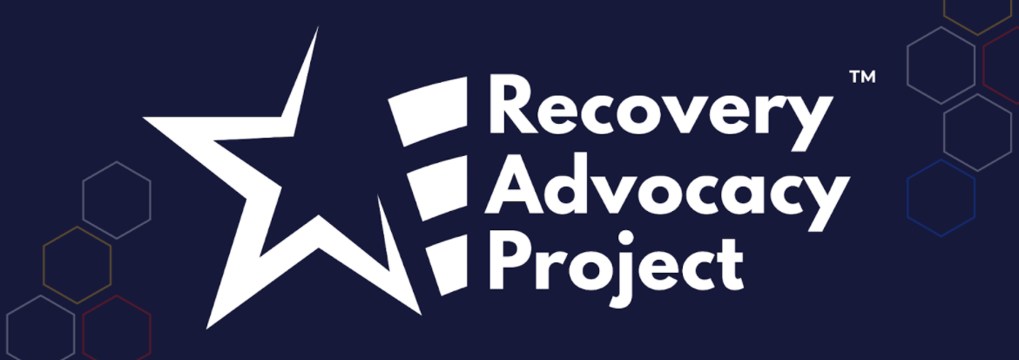
ORGANIZING INSTITUTE

ACKNOWLEDGEMENTS

We welcome your suggestions for improving this guide further for future trainings. We also welcome you to use it and adapt it for your own trainings, subject to the restrictions below.
This workshop guide has been developed over the course of many trainings by Liz Pallatto, Joy Cushman, Jake Waxman, Devon Anderson, Rachel Anderson, Adam Yalowitz, Kate Hilton, Lenore Palladino, New Organizing Institute staff, MoveOn Organizers, Center for Community Change staff, Jose Luis Morantes, Carlos Saavedra, Sean Thomas-Breitfeld, Shuya Ohno, Petra Falcon, Michele Rudy, Hope Wood, Josh Daneshforooz, Melanie Vant, Uyen Doan, Abel R. Cano, Voop de Vulpillieres and many others.

RESTRICTIONS OF USE

The following work [this workshop guide] is provided to you pursuant to the following terms and conditions. Your acceptance of the work constitutes your acceptance of these terms:
- You may reproduce and distribute the work to others for free, but you may not sell the work to others.
- You may not remove the legends from the work that provide attribution as to source (i.e., “originally adapted from the works of Marshall Ganz of Harvard University”).
- You may modify the work, provided that the attribution legends remain on the work, and provided further that you send any significant modifications or updates to marshall_ganz@harvard.edu or Marshall Ganz, Hauser Center, Harvard Kennedy School, 79 JFK Street, Cambridge, MA 02138
- You hereby grant an irrevocable, royalty-free license to Marshall Ganz and New Organizing Institute, and their successors, heirs, licensees and assigns, to reproduce, distribute and modify the work as modified by you.
- You shall include a copy of these restrictions with all copies of the work that you distribute and you shall inform everyone to whom you distribute the work that they are subject to the restrictions and obligations set forth herein.

If you have any questions about these terms, please contact marshall_ganz@harvard.edu or Marshall Ganz, Hauser Center, Harvard Kennedy School, 79 JFK Street, Cambridge, MA 02138.

INTRODUCTION TO PUBLIC NARRATIVE & STORY OF SELF

Goals for this session:
- Learn WHY Public Narrative is an essential leadership skill
- Learn HOW Public Narrative works: values, emotion & story structure
- Learn HOW to tell your public narrative

If I am not for myself, who will be for me?
When I am only for myself, what am I?
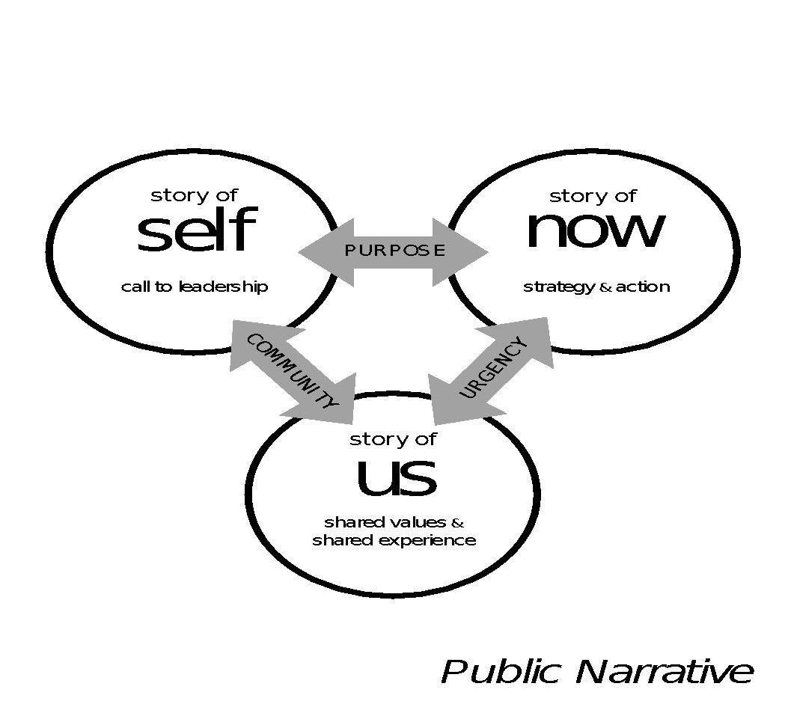
If not now, when?

- Hillel, 1st century Jerusalem sage
Crafting a complete public narrative is a way to connect three core elements of leadership practice: story (why we must act now, heart), strategy (how we can act now, head), and action (what we must do to act now, hands). As Rabbi Hillel’s powerful words suggest, to stand for yourself is a first but insufficient step. You must also construct the community with whom you stand and move that community to act together now. To combine stories of self, us and now, find common threads in values that call you to your mission, values shared by your community, and challenges to those values that demand action now. You may want to begin with a Story of Now, working backward through the Story of the Us with whom you are working to the Story of Self in which your calling is grounded.

Public narrative as a leadership practice
Leadership is about accepting responsibility for enabling others to achieve shared purpose in the face of uncertainty. Narrative is how we learn to access the moral resources – the courage – to make the choices that shape our identities – as individuals, as communities, as nations.

Each of us has a compelling story to tell
Each of us can learn to tell a story that can move others to action. We each have stories of challenge, or we wouldn’t think the world needed changing. And we each have stories of hope, or we wouldn’t think we could change it. As you learn this skill, you will learn to tell a story about yourself (story of self), the community whom you are organizing (story of us), and the action required to create change (story of now). You will learn to tell, to listen, and to coach others.

Learning Public Narrative
We are all natural storytellers. We are “hard wired” for it. Although you may not have learned how to tell stories “explicitly” (their structure, the techniques), you have leaned “implicitly” (imitating others, responding to the way others react to you, etc.). In this workshop you will learn the tools to make the implicit explicit. We will use a four-stage pedagogy: explain, model, practice and debrief. We will explain how story works, you will observe a model of story telling, you will then practice you own story, and you will then debrief your practice with others.
You will learn this practice the way we learn any practice: the same way we learn to ride a bike. Whatever we read, watch, or are told about bike riding, sooner or later we have to get on. And the first thing that usually happens is that you fall off. Then, and this is the key moment, you either give up or find the courage to get back up on the bike, knowing you will continue to fall, until, eventually you learn to keep your balance. In this workshop you’ll have the support of your written materials, peers and coaches.
You will also learn to coach others in telling their stories. We are all “fish” so to speak in the “water” of our own stories. We have lived in them all our lives and so we often need others to ask us probing questions, challenge us to explain why, and make connections we may have forgotten about so we can tell our stories in ways others can learn from them.
We all live rich, complex lives with many challenges, choices, and outcomes of both failure and success. We can never tell our whole life story in two minutes. We are learning to tell a two-minute story as the first step in mastering the craft of public narrative. The time limit focuses on getting to the point, offering images rather than lots of words, and choosing choice points strategically.

How Public Narrative Works

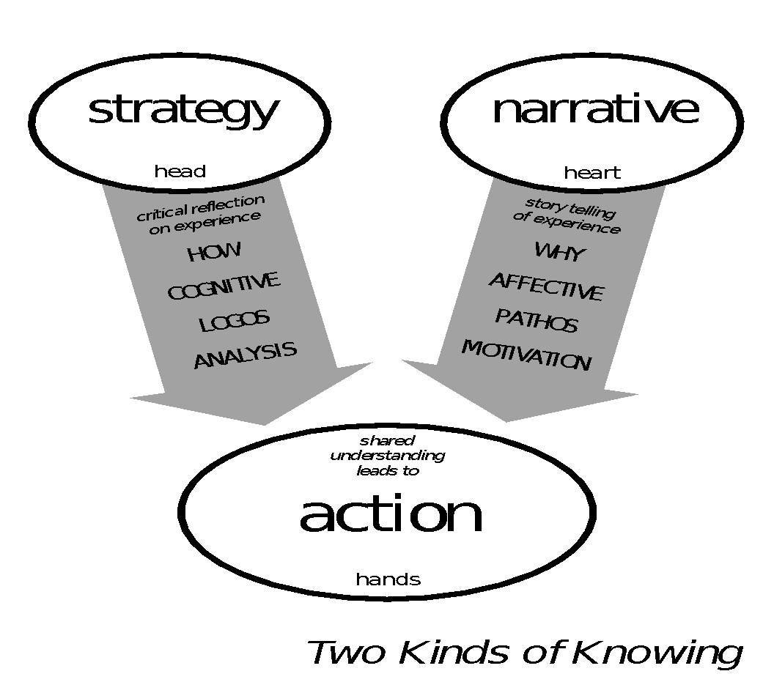
Why use public narrative? Two ways of knowing (and why we need both!)
Leadership requires engaging the “head” and the “heart” to engage the “hands”—mobilizing others to act together purposefully. Leaders engage people in interpreting why they should change their world—their motivation—and how they can act to change it—their strategy. Public narrative is the “why”—the art of translating values into action through stories.

The key to motivation is understanding that values inspire action through emotion.
Emotions inform us of what we value in ourselves, in others, and in the world, and enable us to express the motivational content of our values to others. Stories draw on our emotions and show our values in action, helping us feel what matters, rather than just thinking about or telling others what matters. Because stories allow us to express our values not as abstract principles, but as lived experience, they have the power to move others.

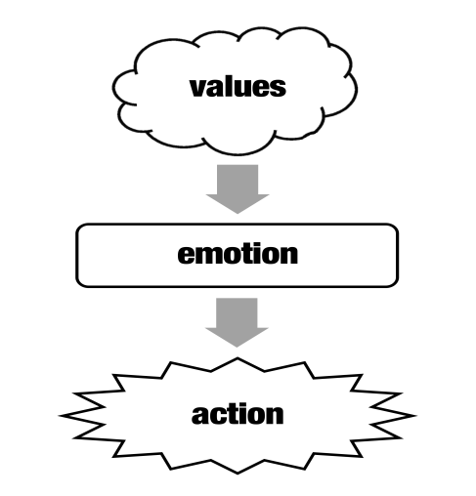

Some emotions inhibit action, but other emotions facilitate action.
The language of emotion is the language of movement, sharing the same root word. Mindful action is inhibited by inertia and apathy, on the one hand, and fear, isolation and self-doubt on the other. It can be facilitated by urgency and anger, on one hand, and hope, solidarity, and YCMAD (you can make a difference) on the other. Stories can mobilize emotions enabling mindful action to overcome emotions that inhibit it.
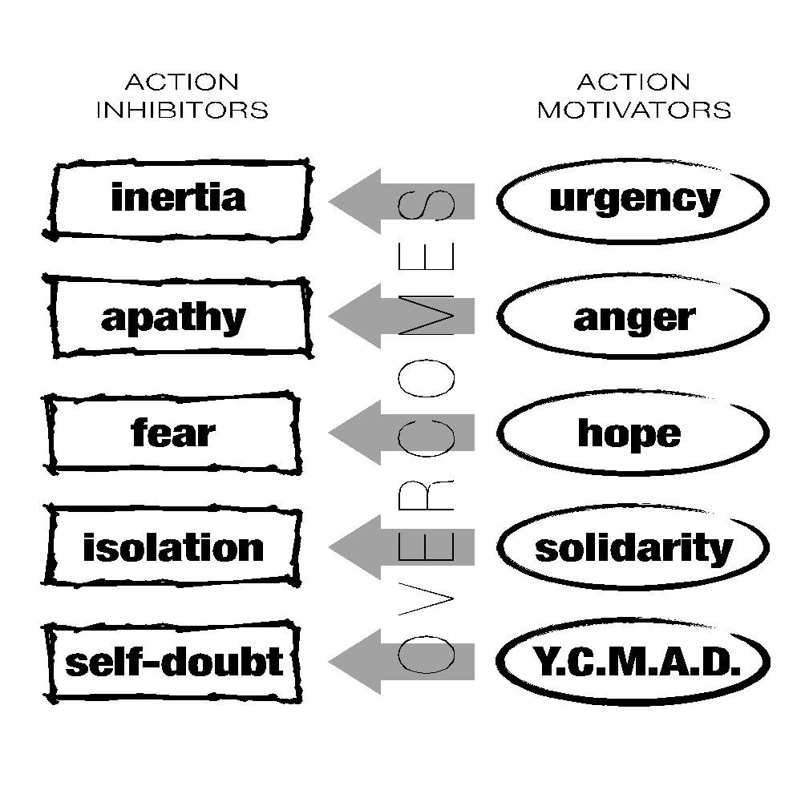

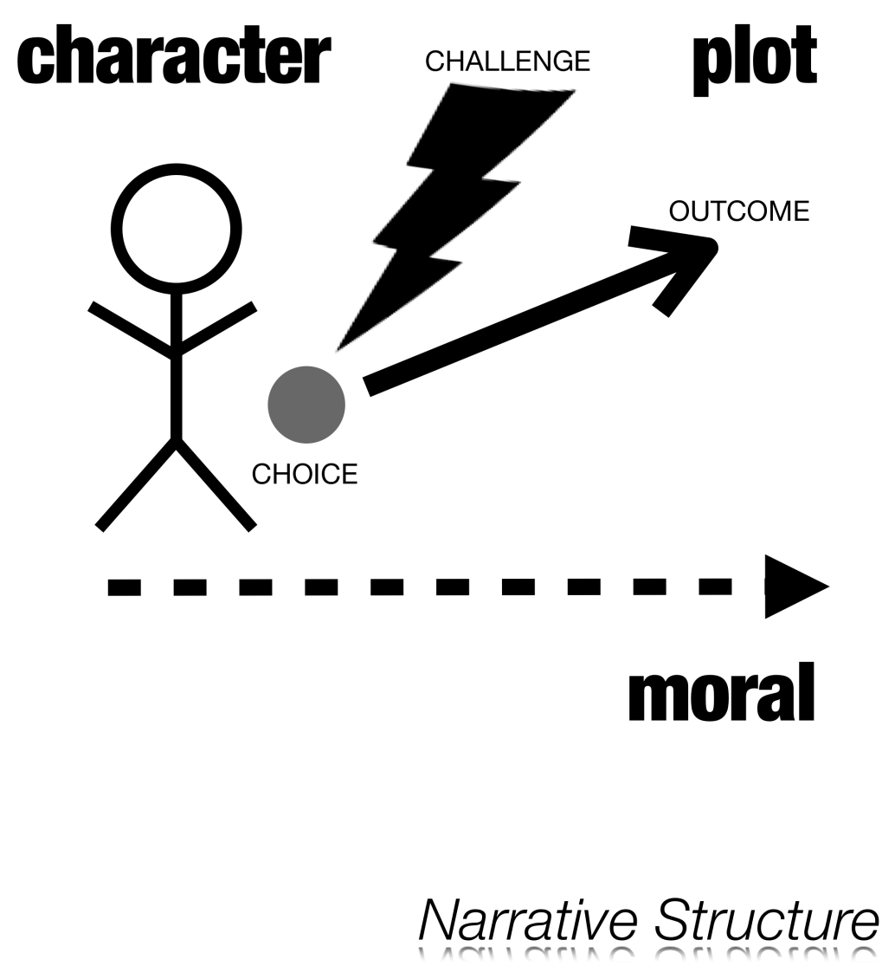
The Three Key Elements of Public Narrative Structure: Challenge – Choice – Outcome
A plot begins with an unexpected challenge that confronts a character with an urgent need to pay attention, to make a choice, a choice for which s/he is unprepared. The choice yields an outcome—and the outcome teaches a moral.
Because we can empathetically identify with the character, we can “feel” the moral. We not only hear “about” someone’s courage; we can also be inspired by it.
The story of the character and their effort to make choices encourages listeners to think about their own values, and challenges, and inspires them with new ways of thinking about how to make choices in their own lives.

Incorporating Challenge, Choice, and Outcome in Your Own Story
There are some key questions you need to answer as you consider the choices you have made in your life and the path you have taken that brought you to this point in time as a leader. Once you identify the specific relevant choice point—perhaps your first true experience of community in the face of challenge, or your choice to do something about injustice for the first time—dig deeper by answering the following questions.
Challenge: Why did you feel it was a challenge? What was so challenging about it? Why was it your challenge?
Choice: Why did you make the choice you did? Where did you get the courage (or not)? Where did you get the hope (or not)? Did your parents or grandparents’ life stories teach you in any way how to act in that moment? How did it feel?
Outcome: How did the outcome feel? Why did it feel that way? What did it teach you? What do you want to teach us? How do you want us to feel?

A word about challenge. Sometimes people see the word challenge and think that they need to describe the misfortunes of their lives. Keep in mind that a struggle might be one of your own choosing – a high mountain you decided to climb as much as a valley you managed to climb out of. Any number of things may have been a challenge to you and be the source of a good story to inspire others.

Public narrative combines a story of self, a story of us, and a story of now.
A “story of now” communicates an urgent challenge you are calling on your community to join you in acting on now.
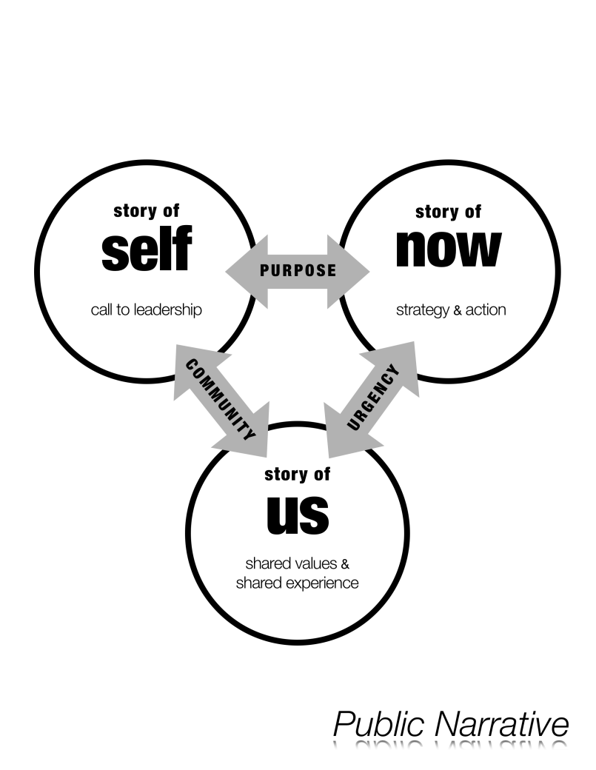
A story of now requires telling stories that bring the urgency of the challenge you face alive – urgent because of a need for change that cannot be denied, urgent because of a moment of opportunity to make change that may not return. At the intersection of the urgency of challenge and the promise of hope is a choice that must be made – to act, or not to act; to act in this way, or in that. The hope resides not somewhere in a distant future but in the sense of possibility in a pathway to action. Telling a good story of now requires the courage of imagination, or as Walter Brueggemann named it, a prophetic imagination, in which you call attention both to the pain of the world and also to the possibility for a better future.
A “story of us” communicates shared values that anchor your community, values that may be at risk, and may also be sources of hope.
We tell more “stories of us” in our daily lives than any other kind of story: “do you remember when” moments at a family dinner, “what about the time that” moments after an exciting athletic event, or simply exchanging stories with friends. Just like any good story, stories of us recount moments when individuals, a group, a community, an organization, a nation experienced a challenge, choice, and outcome, expressive of shared values. The may be founding moments, moments of crisis, of triumph, disaster, of resilience, of humor. The key is to focus on telling specific stories about specific people at specific times that can remind everyone of–or call everyone’s attention to–the values that you share against which challenges in the world can be measured. A “story of us”, however, is “experiential” in that it creates an experience of shared values, rather than “categorical”, described by certain traits, characteristics, or identity markers. Telling a good story of us requires the courage of empathy – to consider the experience of others deeply enough to take a chance of articulating that experience.
A “story of self” communicates the values that called you to lead in this way, in this place, at this time.
Each of us has compelling stories to tell. In some cases, our values have been shaped by choices others – parents, friends, and teachers – have made. And we have chosen how to deal loss, even as we have found access to hope. Our choices have shaped our own life path: we dealt with challenges as children, found our way to a calling, responded to needs, demands, and gifts of others; confronted leadership challenges in places of worship, schools, communities, work.

VIDEO REVIEW:

Amal Beydoun

We'll be watching two minutes of Amal Beydoun’s Story of Self. As you watch it, focus on the elements of Story of Self that you hear in her story.

CHALLENGE | CHOICE | OUTCOME
What experiences shaped her values? What details and images bring her challenge alive? | What moments of choice does she recall? What are the values? | Where does she locate the source of hope? What is the outcome of her choices?

- Why does Amal Beydoun begin as she does?

- What details, images, and moments bring her story alive?

- What values does her story communicate?

WORKSHEET:

DEVELOPING YOUR STORY OF SELF
Before you decide what part of your story to tell, think about these questions:
- Why am I called to leadership in recovery, not just to recover myself?
- What values move me to act and might they inspire others to similar action?
- What stories can I tell from my own life about specific people or events that would show (rather than tell) how I learned or acted on those values?
What early moments shaped the values that call you to leadership?

Think about the challenge, choice and outcome in your story. The outcome might be what you learned, in addition to what happened. Try drawing pictures here instead of words. Powerful stories leave your listeners with images in their minds that shape their understanding of you and your calling. Remember, articulating the decisions you make in the face of challenges ultimately communicates your values.
CHALLENGE: | CHOICE:  (and where did your hope and strength come from?) | OUTCOME:

TEAM BREAKOUT SESSION:

STORY OF SELF PRACTICE WORK

GOALS
- Practice telling your Story of Self and get constructive feedback
- Learn to draw out and coach the stories of others

AGENDA
TOTAL TIME: 17 min.
 | Choose a timekeeper and first storyteller. | 2 min.
 | As a team go around the group and tell your story one by one.  For each person:  - 2 minutes to tell their story  - 3 minutes to offer feedback from the group  Listeners, follow your genuine curiosity about the storyteller as a person. Do you truly get why they are called to their leadership? You may want to consider asking one these questions, if it is not clear from the story:  - When did you learn your resiliency and strength?  - When in your childhood did you learn that you could make change?  - When did you first choose to support others and take leadership?  - When in your childhood did you learn that the world was unjust?  - What do you do today, and why?  - What values really drive your leadership today?  NOTE: You have just 2 minutes to tell your story. Stick to this limit. Make sure your timekeeper cuts you off. This encourages focus and makes sure everyone has a chance to tell their story. | 15 min.
For Further Reflection
We all live very rich and complex lives with many challenges, many choices, and many outcomes of both failure and success. That means we can never tell our whole life story in 2 minutes. The challenge is to learn to interpret our life stories as a practice, so that we can teach others based on reflection and interpretation of our own experiences, and choose stories to tell from our own lives based on what’s appropriate in each unique situation.
Take time to reflect on your own public story, beginning with your story of self. You may go back as far as your parents or grandparents, or you may start with your most recent organizing and keep asking yourself why in particular you got involved when you did. Focus on challenges you had to face, the choices you made about how to deal with those challenges, and the satisfactions – or frustrations—you experienced. Why did you make those choices? Why did you do this and not that? Keep asking yourself why.
What did you learn from reflecting on these moments of challenge, choice, and outcome? How do they feel? Do they teach you anything about yourself, about your family, about your peers, your community, your nation, your world around you—about what really matters to you? What about these stories was so intriguing? Which elements offered real perspective into your own life?
What brings you to this campaign? When did you decide to work on improving education, for instance? Why? When did you decide to volunteer? Why? When did you decide to give up a week to come to this workshop? Why?
Many of us active in public leadership have stories of both loss and hope. If we did not have stories of loss, we would not understand that loss is a part of the world; we would have no reason to try to fix it. But we also have stories of hope. Otherwise we wouldn’t be trying to fix it.

A good public story is drawn from the series of choice points that structure the “plot” of your life – the challenges you faced, choices you made, and outcomes you experienced.
Challenge: Why did you feel it was a challenge? What was so challenging about it? Why was it your challenge?
Choice: Why did you make the choice you did? Where did you get the courage – or not? Where did you get the hope – or not? How did it feel?
Outcome: How did the outcome feel? Why did it feel that way? What did it teach you? What do you want to teach us? How do you want us to feel?

COACHING TIPS:

STORY OF SELF

Remember to balance both positive and constructive critical feedback. The purpose of coaching is to listen to the way stories are told and think of ways that the storytelling could be improved.

DON’T simply offer vague “feel good” comments. (“That was a really great story!”)
DO coach each other on the following points:

- THE CHALLENGE: What were the specific challenges the storyteller faced? Did the storyteller paint a vivid picture of those challenges?
“When you described ________, I got a clear picture of the challenge.”
“I understood the challenge to be ________. Is that what you intended?”
“The challenge wasn’t clear. How would you describe ________?”

- THE CHOICE: Was there a clear choice that was made in response to each challenge? How did the choice make you feel? (Hopeful? Angry?)
“To me, the choice you made was _______, and it made me feel _______.”
“It would be helpful if you focused on the moment you made a choice.”

- THE OUTCOME: What was the specific outcome that resulted from each choice? What does that outcome teach us?
“I understood the outcome to be _______, and it teaches me _______. But how does it relate to your work now?”

- THE VALUES: Could you identify what this person’s values are and where they came from? How? How did the story make you feel?
“Your story made me feel ________ because _________.”
“It’s clear from your story that you value _______; but it could be even clearer if you told a story about where that value comes from.”

- DETAILS: Were there sections of the story that had especially good details or images (e.g. sights, sounds, smells, or emotions of the moment)?
“The image of ________ really helped me identify with what you were feeling.”
“Try telling more details about _______ so we can imagine what you were experiencing.”

Record Feedback/Comments from Your Team Members Here:

Coaching Your Team's “Story of Self’: As you hear each other's stories, keeping track of the details of each person’s story will help you to provide feedback and remember details about people on your team later. Use the grid below to track your team's stories in words or images.

NAME | VALUES | CHALLENGE | CHOICE | OUTCOME

VIDEO REVIEW: Self-Us-Now

We'll be watching five minutes of a Linked Public Narrative. As you watch it, focus on the elements of SELF – US – NOW that you hear in the story.

SELF | US | NOW
What experiences shaped the storyteller’s values? Whose choices were they? Why are they stories? | Who is the “us” to whom they appeal? What moments of choice do they recall? What are the values? | What challenges to those values do they describe? What’s the source of hope? In what action do they ask us to join?
Moments of challenge:  Moments of choice & hope: | Moments of challenge:  Moments of choice & hope: | Moments of challenge:  Moments of choice & hope:  Ask:

- What challenge, choice, and outcome are at the core of each story: self, us and now?

- What details, images, moments bring the story alive?

- What values does the story communicate?

