FICPFM ORGANIZER TRAINING FELLOWSHIP

WINNING CAMPAIGNS TO TRANSFORM THE CRIMINAL JUSTICE SYSTEM DURING COVID-19 & BEYOND

DIGITAL MANUAL

Adapted for this training by Abel R. Cano, Anjali Rodrigues, and Miya Cain. Modified for digital distribution by Jeff Rousset in 2018.

Originally adapted from the works of Marshall Ganz of Harvard University.

Originally adapted from the works of Marshall Ganz of Harvard University
http://www.hks.harvard.edu/about/faculty-staff-directory/marshall-ganz

Modified by the New Organizing Institute
http://www.neworganizing.com

Designed by Zac Willette

ACKNOWLEDGEMENTS

We welcome your suggestions for improving this guide further for future trainings. We also welcome you to use it and adapt it for your own trainings, subject to the restrictions below.
This workshop guide has been developed over the course of many trainings by Liz Pallatto, Joy Cushman, Jake Waxman, Devon Anderson, Rachel Anderson, Adam Yalowitz, Kate Hilton, Lenore Palladino, New Organizing Institute staff, MoveOn Organizers, Center for Community Change staff, Jose Luis Morantes, Carlos Saavedra, Sean Thomas-Breitfeld, Shuya Ohno, Petra Falcon, Michele Rudy, Hope Wood, Josh Daneshforooz, Melanie Vant, Uyen Doan, Voop de Vulpillieres, Abel R. Cano and many others.

RESTRICTIONS OF USE

The following work [this digital guide] is provided to you pursuant to the following terms and conditions. Your acceptance of the work constitutes your acceptance of these terms:

- You may reproduce and distribute the work to others for free, but you may not sell the work to others.
- You may not remove the legends from the work that provide attribution as to source (i.e., “originally adapted from the works of Marshall Ganz of Harvard University”).
- You may modify the work, provided that the attribution legends remain on the work, and provided further that you send any significant modifications or updates to marshall_ganz@harvard.edu or Marshall Ganz, Hauser Center, Harvard Kennedy School, 79 JFK Street, Cambridge, MA 02138
- You hereby grant an irrevocable, royalty-free license to Marshall Ganz and New Organizing Institute, and their successors, heirs, licensees and assigns, to reproduce, distribute and modify the work as modified by you.
- You shall include a copy of these restrictions with all copies of the work that you distribute and you shall inform everyone to whom you distribute the work that they are subject to the restrictions and obligations set forth herein.

If you have any questions about these terms, please contact marshall_ganz@harvard.edu or Marshall Ganz, Hauser Center, Harvard Kennedy School, 79 JFK Street, Cambridge, MA 02138.
table of contents

Introduction………………………………………………………...……………….. p. 4

People, Power, Change: What are the core leadership practices for organizing? .... p. 7

Leadership Practice: Public Narrative 1 - Story of Self…………………………….. p. 20

Leadership Practice: Relationship Building……………………………………...… p. 34

Leadership Practice: Building Leadership Teams……………………………....….. p. 44

Leadership Practice: Public Narrative 2 - Story of Us………………………..……. p. 55

Leadership Practice: Devising Shared Strategy……………………………….…… p. 66

Leadership Practice: Mobilizing Shared Commitment - Action…………..……….. p. 85

Leadership Practice: Public Narrative 3 - Story of Now and Linking Self+Us+Now p. 97

Appendix: Coaching as a leadership practice……………………..……………... p. 109

INTRODUCTION

What is the purpose of this manual?

Introduction

The goal of this manual is to introduce you to an organizer’s perspective on leadership. Organizing can be learned as a leadership practice based on accepting responsibility for enabling others to achieve purpose under conditions of uncertainty: identifying, recruiting and developing leadership, building a constituency around that leadership, and transforming the resources of that constituency into the power they need to achieve their purposes.

This manual features links to multimedia resources. It was originally designed as a printed participant manual to be used during and after in-person organizing workshops. Since many of the resources used for workshops and related materials are now available digitally, we hope this manual will be useful for civic engagement practitioners who may or may not have attended workshops in person. Of course reading this manual will not be enough to produce any deep learning. This manual is meant to accompany practice and reflection, both individually and in leadership teams. We hope you will put it to good use in your campaigns!

There are five basic organizing leadership practices covered in this guide:
  - How to translate values into the motivation for action by learning to tell a story of why you are called to lead, a story of your constituency, and a story of an urgent challenge that requires action: self, us, and now.
  - How to build intentional relationships as the foundation of purposeful collective action.
  - How to structure a collaborative leadership team with shared purpose, ground rules and clear roles.
  - How to strategize turning the resources of one’s constituency into the power needed to achieve clear goals.
  - How to secure commitments required to generate measurable, motivational, and effective collective action.

- - -
PERSONAL REFLECTIONS

Why are you interested in organizing to build power?

What leadership skills do you possess?

What kinds of skills are you interested in learning?

What contributions do you see yourself making?

PEOPLE, POWER, AND CHANGE

What are the core leadership practices for organizing?

PEOPLE, POWER, AND CHANGE

Goals for this section:

To introduce our approach to leadership, organizing and learning.
To introduce 5 key organizing practices on which we will focus.
To focus on the relationship among people, power, and change.
To introduce 5 core practices of interdependent leadership

What is Leadership?

Leadership in organizing is rooted in three questions articulated by the first century Jerusalem sage, Rabbi Hillel:
“If I am not for myself, who am I?
When I am only for myself, what am I?
And if not now, when?

These three questions focus on the interdependence of self, other, and action: what am I called to do, what are others with whom I am in relationship called to do, and what action does the world in which we live demand of us now?

The fact these are framed as questions, not answers, is important: to act is to enter a world of uncertainty, the unpredictable, and the contingent. Do we really think we can control it? Or do we have to learn to embrace it? Uncertainty poses challenges to the hands, the head and the heart. What new skills must my “hands” learn? How can my “head” devise new ways to use my resources to achieve my goals? How can my “heart” equip me with the courage, hopefulness, and forbearance to act?

Leadership requires “accepting responsibility for enabling others to achieve purpose under conditions of uncertainty”. Conditions of uncertainty require the “adaptive” dimension of leadership: not so much performing known tasks well, but, rather learning what tasks are needed and performing them well. It is leadership from the perspective of a “learner” – one who has learned to ask the right questions – rather than that of a “knower” – on who thinks he or she knows all the answers. This kind of leadership is a form of practice - not a position or a person – and it can be exercised from any location within or without a structure of authority. Leadership is taking responsibility for enabling others to achieve shared purpose under conditions of uncertainty.

What is Organizing?

Organizing is a form of leadership that enables a constituency to turn its resources into the power to achieve its goals through recruitment, training, and development of leadership. Organizing is about equipping people (constituency) with the power (story and strategy) to make change (real outcomes).

PEOPLE: Organizing a constituency

The first question an organizer asks is not “what is my issue” but “who are my people” – who is my constituency. A constituency is a group of people who learn to “stand together” to decide, assert, and act upon their own goals. Organizing is not only about solving problems. It is about enabling the people with the problem to mobilize their own resources to solve it . . . and keep it solved.

POWER: What is it, where does it come from, how does it work?

Rev. Martin Luther King described power as the “ability to achieve purpose.” We all require resources to achieve our purposes. Few if any of us control all the resources we need to achieve all our purposes. But your interest in my resources and my interest in your resources may give us a common interest in combining our resources to achieve a common purpose (power with). But if I need your resources more than you need my resources, you may be able to get what you need at my expense (power over). So power is not a thing, quality, or trait – it is the influence created by the relationship between interests and resources. You can “track down the power” asking—and getting the answers to—four questions:

- What are the interests of your constituency?
- Who holds the resources needed to address these interests?
- What are the interests of the individuals or organizations who hold these resources?
- What resources does your constituency hold which the other individuals or organizations need to address their interests?

Our power comes from people. Because powerlessness is the source of so many of the problems people face, organizing not only enables people to solve those problems, but also, by working together, to become more powerful people.

So organizing is not only a commitment to identify more leaders, but also a commitment to engage those leaders in building the power to create the change we need in our lives. Organizing power begins with a decision by the first person who wants to make it happen to commit. Without this commitment, there are no resources with which to begin. Commitment is as observable as action. The work of organizers begins with a decision to accept responsibility to challenge others to do the same.

CHANGE: What kind of change can organizing make?

What urgent problems do your people face? How might the world look different if those problems were solved? What first steps can they take to begin solving those problems? Change is specific, concrete, and significant. It requires focus on a goal that will make a real difference that we can see. It is not about “creating awareness”, having a meaningful conversation, or giving a great speech. It is about specifying a clearly visible goal, explaining why achieving that goal can make a real difference in meeting the challenge that your constituency has to face, and making it happen.

Five Organizing Practices

Learning how to organize people to build the power they need to make change begins with learning five key leadership practices.

DISORGANIZATION | LEADERSHIP | ORGANIZATION
Passive | Shared Story | Active
Divided | Relational Commitment | United
Drift | Clear Structure | Purpose
Reactive | Creative Strategy | Initiative
Demobilized | Effective Action | Mobilized

1. Creating Shared Story:

Organizing is motivated by shared values expressed through public narrative. By learning the craft of public narrative we can access our shared values for the emotional resources we need to respond to challenges with courage rather than reacting to them with fear. By learning to tell stories of sources of our own values, a “story of self”, we enable people to “get us”. By telling stories of the sources of values we share, a “story of us”, we enable people to “get” each other. By recognizing the current moment as one of urgent choice and proposing a hopeful way forward, a “story of now”, we motivate action. Values-based organizing—in contrast to issue-based organizing—invites people to escape their “issue silos” and come together so that their diversity becomes an asset, rather than an obstacle. By learning how to tell a public narrative that bridges the self, us, and now, organizers enhance their own efficacy and create trust and solidarity within their campaign, equipping them to engage others far more effectively.

2. Creating Shared Relational Commitment:

Organizing is based on relationships and creating mutual commitments to work together. It is the process of association—not simply aggregation—that makes a whole greater than the sum of its parts. Through association we can learn to recast our individual interests as common interests, identify values we share, and envision objectives that we can use our combined resources to achieve. And because it makes us more likely to act to assert those interests, relationship building goes far beyond delivering a message, extracting a contribution, or soliciting a vote. Relationships built as a result of one-on-one meetings create the foundation of local campaign teams, and they are rooted in commitments people make to each other, not simply commitment to an idea, task, or issue.

3. Creating Shared Structure

A team leadership structure can enable organizing that grows stronger through collaborative and cascading leadership development. Volunteer efforts often flounder due to a failure to develop reliable, consistent, and creative individual leaders. Structured leadership teams encourage stability, motivation, creativity, and accountability—and use volunteer time, skills, and effort effectively. They create a structure within which energized volunteers can accomplish challenging work. Real teams can achieve the goals they set for themselves, grow more effective as a team over time, and enable the growth, development and learning of their individual members. Effective leadership teams must be bounded, stable, and diverse. They must agree on a shared purpose, clear norms, and specific roles.

4. Creating Shared Strategy

Although based on broad values, effective organizing campaigns focus on a clear strategic objective, a way to turn those values into action; e.g., desegregate buses in Montgomery, Alabama; getting to 100% clean electricity; etc. Trans-local campaigns locate responsibility for strategy at the top (or at the center), but are able to “chunk out” strategic objectives in time (deadlines) and space (local areas) as a campaign, allowing significant local responsibility for figuring out how to achieve those objectives. Responsibility for strategizing local objectives empowers, motivates and invests local teams.

5. Creating Shared Measurable Action

Organizing outcomes must be clear, measurable, and specific if progress is to be evaluated, accountability practiced, and strategy adapted based on experience. Measures may include volunteers recruited, money raised, people at a meeting, voters contacted, pledge cards signed, laws passed, etc. Although electoral campaigns enjoy the advantage of very clear outcome measures, any effective organizing drive must come up with the equivalent. Regular reporting of progress to goal creates opportunity for feedback, learning, and adaptation. Training must be provided for all skills (e.g., holding house meetings, phone banking, etc.) to carry out the program. Social media may help enable reporting, feedback, coordination. Transparency must exist as to how individuals, groups, and the campaign as a whole are doing with regard to their progress toward their goal.
---

Organizing Your Constituency

This manual focuses on the design of an organizing campaign, but the real work of organizing is done with one’s constituency. As the chart below shows, organizing is about enabling a constituency to develop the power it needs to assert its interests effectively, not only in this moment, but also in the future. Organizers begin by building a foundation within their constituency. This usually requires one-on-one meetings to learn of people’s real concerns, discern real sources of their problems, figure out power dynamics, and identify, recruit and develop leadership. A campaign is a process through which a constituency can organize itself to create the power it needs to achieve its goals. And by turning their campaign efforts into an organization, they will have the capacity to build on their successes into the future.

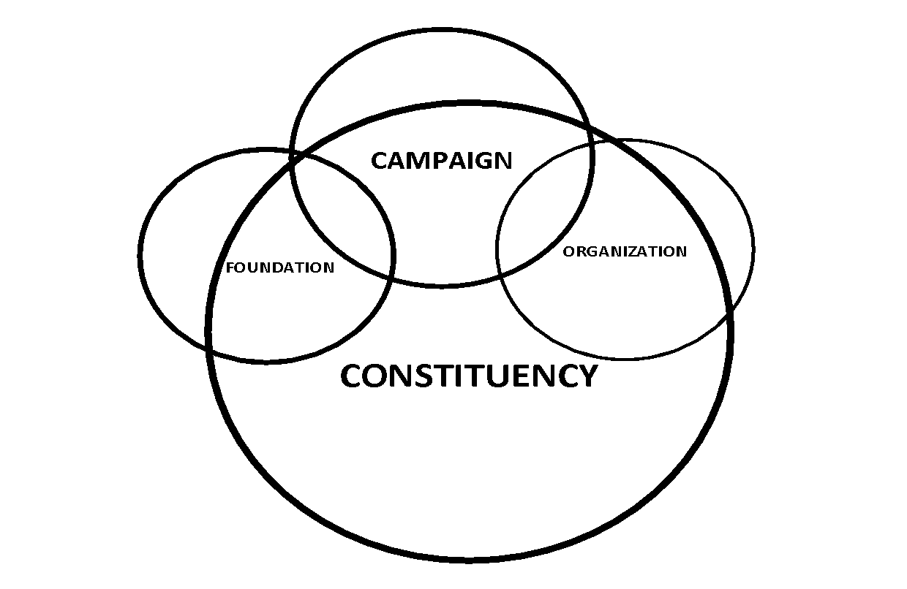

Civic engagement is also organized as a campaign: a way of mobilizing time, resources, and energy to achieve an outcome and treat time as an “arrow,” rather than a “cycle.” Thinking of time as a “cycle” helps to maintain routines, normal procedures, our annual budgets, etc. Thinking of time as an “arrow” focuses on making change, on achieving specific outcomes, on focusing our efforts. A campaign is time as an “arrow". It is an intense stream of activity that begins with a foundational period, builds to a kick-off, builds to periodic peaks, and culminates in a final peak, followed by a resolution. Our workshop will follow the same pattern, each practice, building on what went before, and creating a foundation for what comes next.

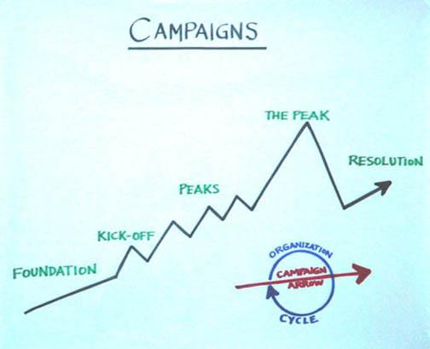

We also take a particular approach to structuring leadership, a structure that enables us to develop the leadership of others, even as we exercise our own. Sometimes we think leadership is about being the person that everyone goes to:

How does it feel to be the dot in the middle of all those arrows? How does it feel to be one of the arrows that can’t even get through? And what happens if the “dot” in the middle should disappear?

Sometimes we think we don’t need leadership at all because “we’re all leaders”, but that looks like this:

Who’s responsible for coordinating everyone? And who’s responsible for focusing on the good of the whole, not just one particular part? With whom does the “buck stop”?

Another way to practice leadership is like this “snowflake”: leadership practices by developing other leaders who, in turn, develop other leaders, all the way “down”. Although you may be the “dot” in the middle, your success depends on developing the leadership of others.

Why is coaching an important organizing practice?

Leadership in organizing is about enabling others to achieve purpose in the face of uncertainty. Coaching enables others.
Organizing campaigns are rich with challenges and learning opportunities, but sometimes we are fish in our own water and we cannot see the challenges we are swimming in. Coaching in organizing helps to alleviate this problem. Coaching helps individuals to overcome motivational, strategic, and informational challenges that might otherwise hinder the progress of the individual, and/or the team, and thus the campaign or training.

What is coaching in organizing?
Coaching is a direct intervention in an individual or team’s work process to help them improve their effectiveness.
Coaching is a leadership practice that is useful in a variety of contexts in organizing campaigns and trainings. Some examples of when coaching skills are necessary:
- Helping an organizer overcome motivational challenges with their volunteers.
- Assisting a leadership team in creating strategy for their organizing campaign.
Coaching is useful whenever we are working to enable others to build their own capacity to act, and though the contexts vary, the process is very similar throughout.
Elements of Coaching
Motivational Coaching
Strategic Coaching

WHY
HOW

Educational Coaching

ACTION

Coaching requires learning to identify a person’s or team’s strengths and weaknesses to help them draw upon their strengths to overcome their weaknesses. People often know what they “should” do. But fresh eyes can help diagnose specific challenges they face while identifying ways to deal with them.
- Motivational (heart) coaching is intended to enhance effort.

- Educational (hands) coaching is intended to help acquire information or skills

- Strategic (head) coaching is intended to help evaluate how to use resources to achieve outcomes.

Coaching Approaches

Corrective
Some coaching is aimed at helping improve poor performance (i.e., the coachee is overall not doing the leadership practice well and needs help getting up to a basic level).

Developmental
Some coaching is aimed at helping the individual achieve mastery (i.e., the coachee does the leadership practice well and is ready to become expert).

Basic elements of coaching are the same (i.e., motivational, strategic, and informational), but coaching strategies may differ (e.g., consult by asking reflective questions to develop mastery vs. consult by providing expert feedback to illustrate errors in how they are thinking about the task).

How Coaching Works – the 5 Step Process
Coaching requires learning how to use four methods to implement 5 steps. The four methods are: asking questions, listening (head and heart), supporting, and challenging. These are the 5 steps.
5-Step Coaching Process
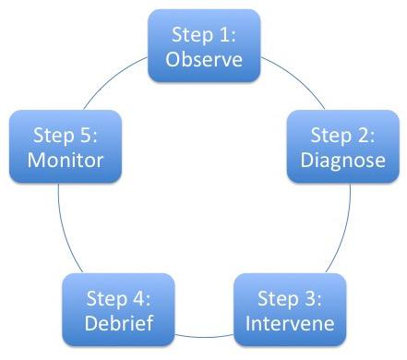

1. Observe: What do I see and hear?
Listen very carefully, observe body language, and ask very focused probing questions to satisfy yourself that you “get” the problem. It may take time to get the facts straight. But if you don’t get the problem, you can’t help solve it. Don’t be shy about asking specific “stubborn” questions. This process can help the coachee articulate just what the problem is in a way they may not have before. So it’s not only “getting information.”

2. Diagnose: Why is the problem a problem?
Getting the diagnosis right really matters. For example, if an organizer is struggling with strategy and you focus on getting them to try harder the result will only be frustration.
Is the challenge motivational (effort/heart)?

Is the individual struggling because s/he is not putting forth enough effort? Is she not trying hard enough because she’s embarrassed? Is he quitting too soon because of frustration or fear? Is s/he getting interference from other habits (e.g., someone well-versed in marketing speak may not know how to tell an authentic story)?

Is the challenge educational (information/skills/hands)?

Is the individual struggling because he lacks the skill to execute effectively? Does he not know how to do it? Is she getting interference from older habits or behaviors (like someone who is so used to selling things confusing this with telling a story of self)? Is it something you could model or role-play with them?

Is the challenge strategic (strategy/head)?

Is the individual struggling because s/he doesn’t know how to use the information or skills that she does have. Does he understand the concepts or underlying principles clearly? Has he not thought it through carefully? Are the goals not achievable? Does the strategy make sense?

3. Intervene – What do I do?
Once you think you’ve figured out what the problem is don’t just tell the coachee what you think he should do! Find out what she thinks she should do? Ask questions that enable the coachee to see the problem, and for you to see how the coachee sees the problem, and discern a way to solve it. Get the coachee’s views out on the table. The appropriate intervention depends on the diagnosis.

If the challenge is motivational, you can:

• Encourage and exhort—you can do it!
• Offer a kick in the pants (with love)
• Help the person confront his or her fear, embarrassment, or other emotion that may get in the way of their ability to risk acting, persevering, trying new things. Communicate with empathy, hope, and affirmation of the coachee’s self-worth. Reward and praise courage
• Model courage and emotional maturity in your own behavior confess fear and explain how you move toward it rather than away from it.

If the challenge is educational, you can:
    - Model the behavior and invite the coachee to imitate you to get the “feel” of the activity
    - Break it down into small parts and invite the individual to try one at a time
    - Offer three or four different practice exercises and observe which ones “take” for that person.
    - Suggest others with whom the person can practice.
    - Suggest ways to figure out where to find the missing information.

If the challenge is strategic, you can
    - Work through a specific example with the person, asking questions to guide the strategic process. Then reflect on the process itself, asking them to describe how it worked?
    - Ask questions about how the individual is thinking about the practice (“Why did you choose that tactic?”)
    - Offer your observations, asking how the person might think about it differently (“At that point, were there other options? What might they have been? Why did you choose the one you did?)
    - Offer feedback on what you are hearing, asking if that describes the situation, at the same time, offering possible reframing of it.
    - Use silent reflection and self-diagnosis (“Why don’t you take a moment to think through what you believe is working and not working and let’s talk about that?).

4. Debrief: What did the “coachee” learn?
Ask your coachee to summarize his or her “take away” from the session, commit to next steps, and decide when you will check back in. What went well? What are you challenged by? What are some possible solutions? What are your goals/next steps?

5. Monitor: How can I continue to support the coachee?
- Schedule periodic check-ins to support your coachee in integrating this new or revised solution into their regular practice.
- Find out from the coachee how the situation has changed.
- Assess whether the diagnosis and intervention was successful. Celebrate success!

Effective coaching is | Effective coaching is not
Showing up and being present to another person’s experience and listening, with both your head and heart | Being so prepared that you work out all the answers for the coachee before you even hear or observe their challenges
Helping the coachee explore and make sense of their challenges and successes, and what they learned from it all | False praising of the coachee or only focusing on their strengths because you do not want to hurt their feelings
Helping the coachee to find solutions to challenges | Solely criticizing the coachee
Asking questions that both support and challenge the person you are coaching | Telling the coachee what to do

Learning Organizing

Organizing is a practice—a way of doing things. It’s like learning to ride a bike. No matter how many books you read about bike riding, they are of little use when it comes to getting on the bike.
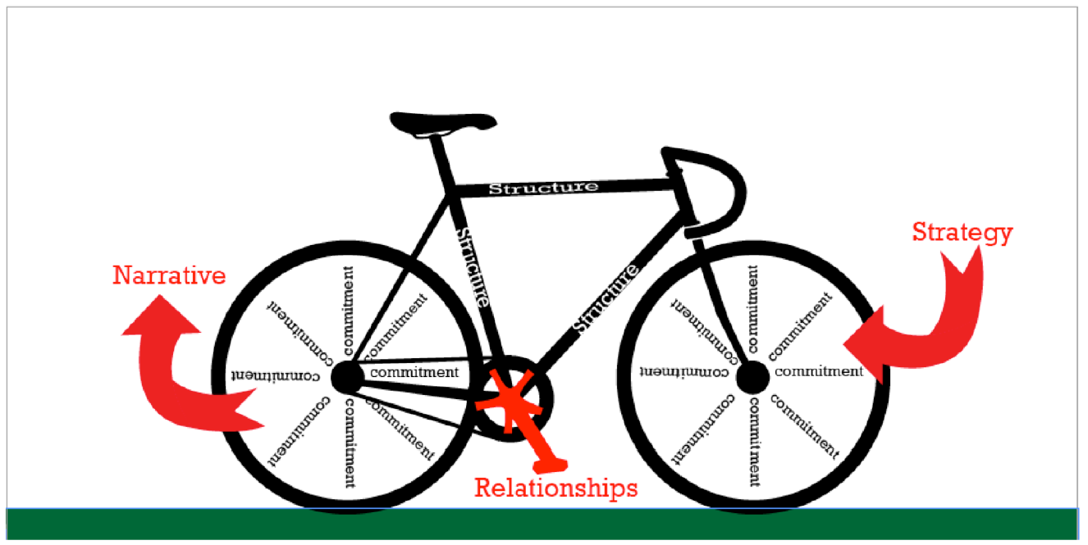
And when you get on the first thing that will happen is that you will fall. And that’s where the “heart” comes in. Either you give up and go home or you find the courage to get back on, knowing you will fall, because that’s the only way to learn to keep your balance. This manual is based on materials originally developed for use during training workshops where the learning came primarily through practicing the five leadership practices, getting feedback, and reflecting on that practice. For this manual to be valuable it should be used to guide action and reflection in your civic engagement work.

PUBLIC NARRATIVE:
STORY OF SELF

Why am I called to leadership?

INTRODUCTION TO PUBLIC NARRATIVE & STORY OF SELF
Goals for this section:

Learn WHY Public Narrative is an essential leadership skill
Learn HOW Public Narrative works: values, emotion & story structure
Learn HOW to tell your public narrative
If I am not for myself, who will be for me?
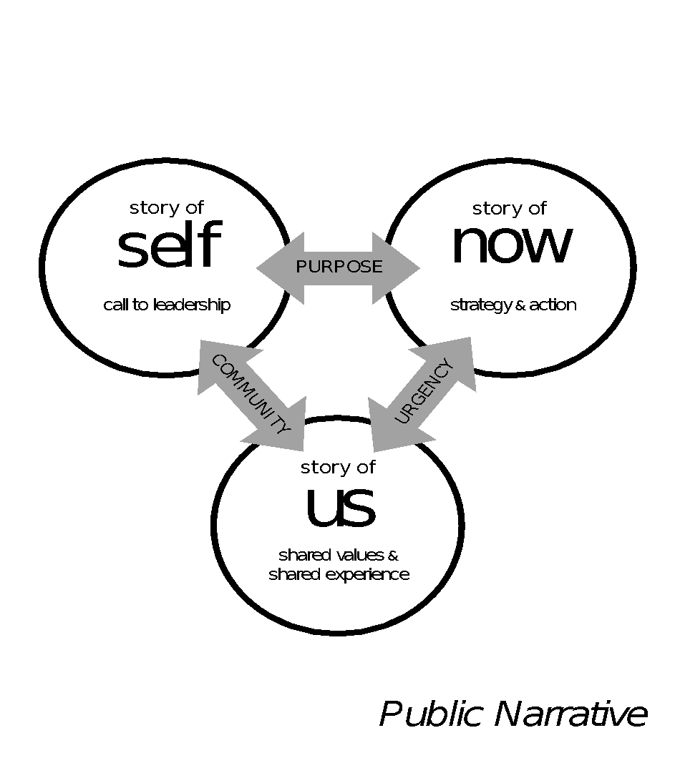
When I am only for myself, what am I?
If not now, when?

- Hillel, 1st century Jerusalem sage

Crafting a complete public narrative is a way to connect three core elements of leadership practice: story (why we must act now, heart), strategy (how we can act now, head), and action (what we must do to act now, hands). As Rabbi Hillel’s powerful words suggest, to stand for yourself is a first but insufficient step. You must also construct the community with whom you stand, and move that community to act together now. To combine stories of self, us and now, find common threads in values that call you to your mission, values shared by your community, and challenges to those values that demand action now. You may want to begin with a Story of Now, working backward through the Story of the Us with whom you are working to the Story of Self in which your calling is grounded.

Public narrative as a leadership practice

Leadership is about accepting responsibility for enabling others to achieve shared purpose in the face of uncertainty. Narrative is how we learn to access the moral resources – the courage – to make the choices that shape our identities – as individuals, as communities, as nations.

Each of us has a compelling story to tell

Each of us can learn to tell a story that can move others to action. We each have stories of challenge, or we wouldn’t think the world needed changing. And we each have stories of hope, or we wouldn’t think we could change it. As you learn this skill, you will learn to tell a story about yourself (story of self), the community whom you are organizing (story of us), and the action required to create change (story of now). You will learn to tell, to listen, and to coach others.

Learning Public Narrative

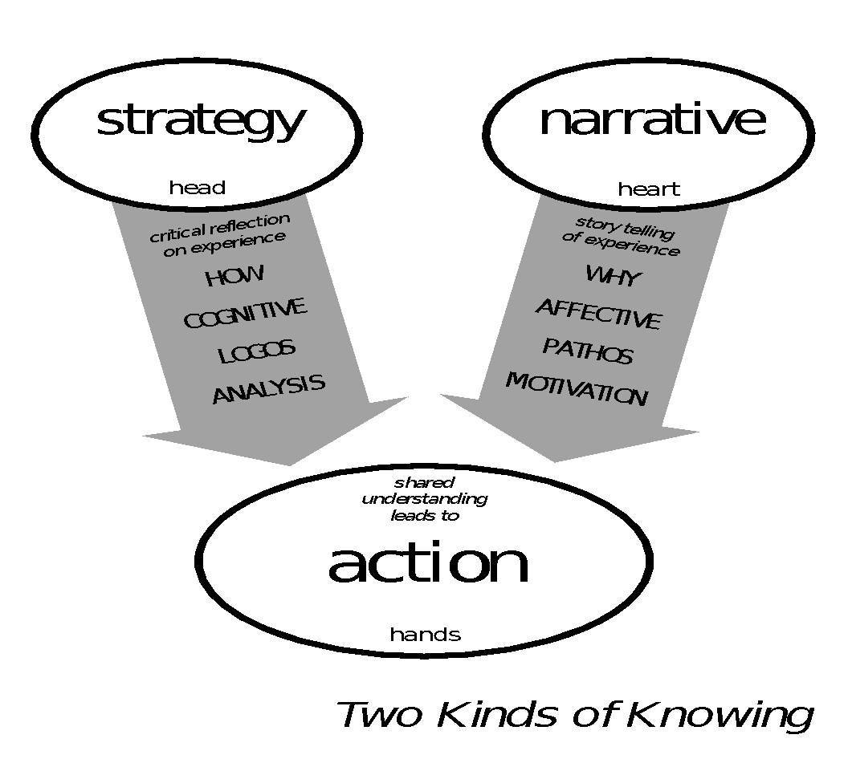
We are all natural storytellers. We are “hard wired” for it. Although you may not have learned how to tell stories “explicitly” (their structure, the techniques), you have learned “implicitly” (imitating others, responding to the way others react to you, etc.). Public Narrative offers tools to make the implicit explicit. In workshops we use a four-stage pedagogy: explain, model, practice and debrief. In this guide, we will explain how story works, then you will observe a model of storytelling by clicking the complementary links, and you can then practice you own story using the worksheets included. Then you can practice telling your story to others and get feedback. Eventually, we hope you will even learn to coach others to develop their Public Narratives!

You will not learn Public Narrative simply by reading this guide. You will learn this practice the way we learn any practice: the same way we learn to ride a bike. Whatever we read, watch, or are told about bike riding, sooner or later we have to get on. And the first thing that usually happens is that you fall off. Then, and this is the key moment, you either give up or find the courage to get back up on the bike, knowing you will continue to fall, until, eventually you learn to keep your balance. Reading this guide is not enough. In order to learn, we encourage you to make the most of this guide by also practicing and exchanging feedback with others. There are exercises attached to help you facilitate this kind of process with peers and coaches.

Another key leadership practice is coaching. Learning to coach others in telling their stories is a powerful way to develop the leadership of your team members and constituents. We are all “fish” so to speak in the “water” of our own stories. We have lived in them all our lives and so we often need others to ask us probing questions, challenge us to explain why, and make connections we may have forgotten about so we can tell our stories in ways others can learn from them.

We all live rich, complex lives with many challenges, choices, and outcomes of both failure and success. We can never tell our whole life story in two minutes. We are learning to tell a two-minute story as the first step in mastering the craft of public narrative. The time limit focuses on getting to the point, offering images rather than lots of words, and choosing choice points strategically.

How Public Narrative Works

Why use public narrative? Research shows that humans have “two ways of knowing” - cognition and emotion - and we need to connect with both to motivate people to take action!

Leadership requires engaging the “head” and the “heart” to engage the “hands”—mobilizing others to act together purposefully. Leaders engage people in interpreting why they should change their world—their motivation—and how they can act to change it—their strategy. Public narrative is primarily the “why”—the art of translating values into action through stories.

The key to motivation is understanding that values inspire action through emotion.
Emotions inform us of what we value in ourselves, in others, and in the world, and enable us to express the motivational content of our values to others. Stories draw on our emotions and show our values in action, helping us feel what matters, rather than just thinking about or telling others what matters. Because stories allow us to express our values not as abstract principles, but as lived experience, they have the power to move others.
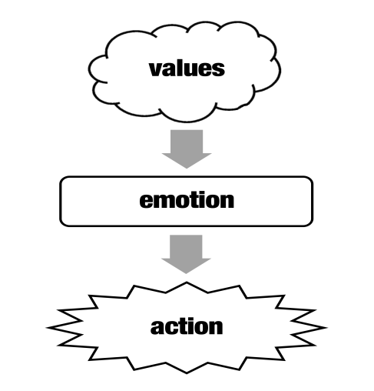

Some emotions inhibit action, but other emotions facilitate action.
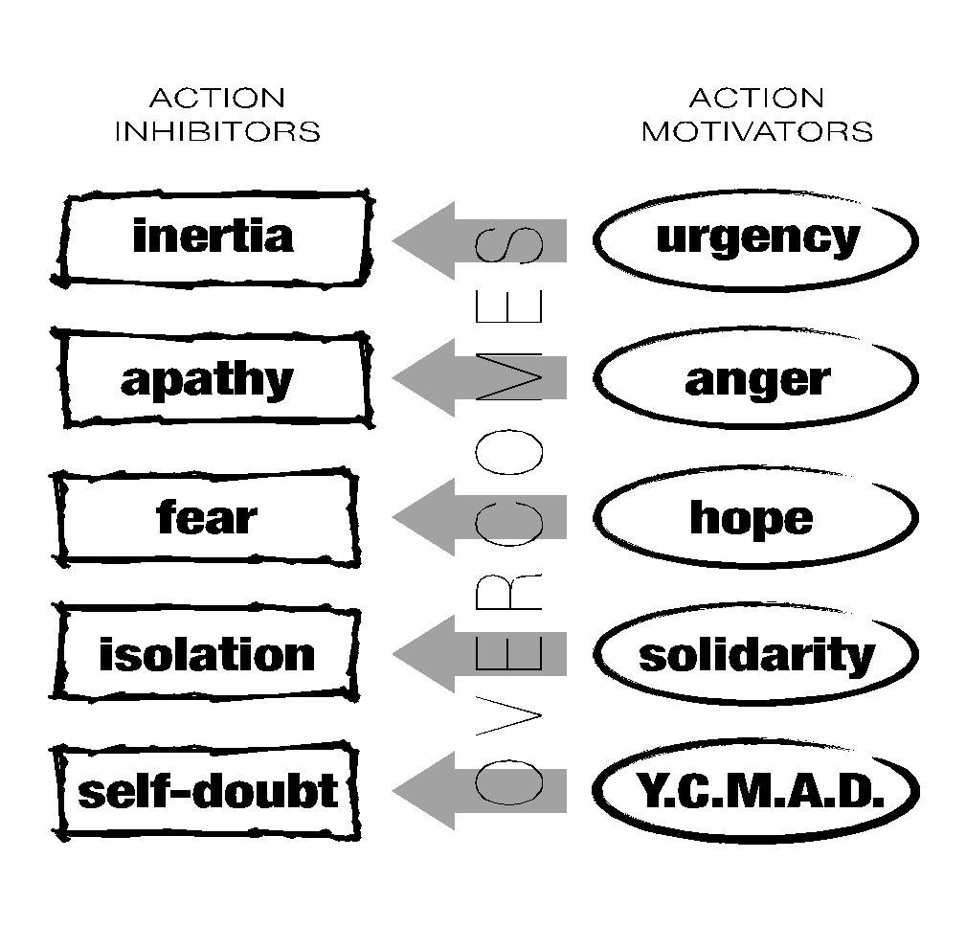
The language of emotion is the language of movement, sharing the same root word. Mindful action is inhibited by inertia and apathy, on the one hand, and fear, isolation and self-doubt on the other. It can be facilitated by urgency and anger, on one hand, and hope, solidarity, and YCMAD (you can make a difference) on the other. Stories can mobilize emotions enabling mindful action to overcome emotions that inhibit it.

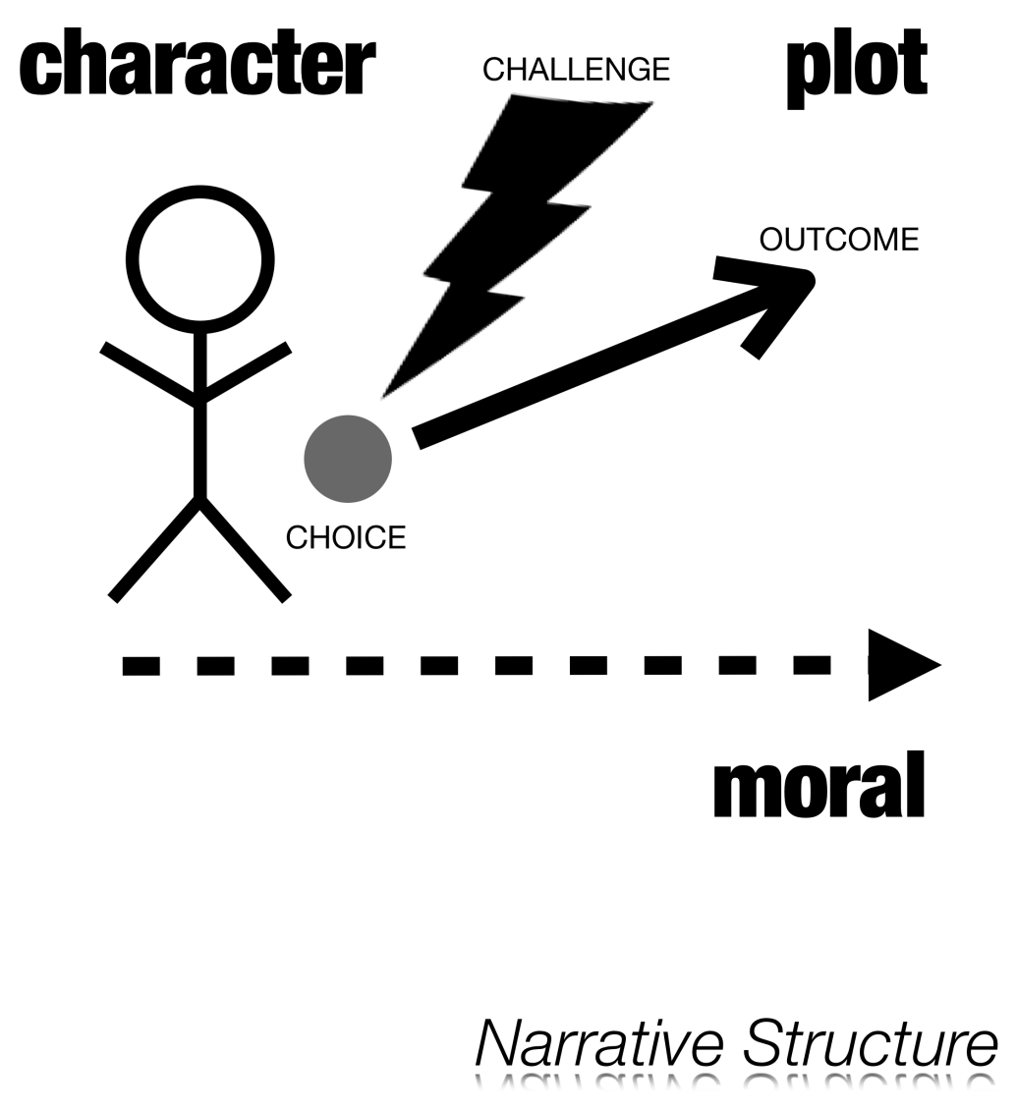
The Three Key Elements of Public Narrative Structure: Challenge – Choice – Outcome
A plot begins with an unexpected challenge that confronts a character with an urgent need to pay attention, to make a choice, a choice for which s/he is unprepared. The choice yields an outcome—and the outcome teaches a moral.

Because we can empathetically identify with the character, we can “feel” the moral. We not only hear “about” someone’s courage; we can also be inspired by it.

The story of the character and their effort to make choices encourages listeners to think about their own values, and challenges, and inspires them with new ways of thinking about how to make choices in their own lives.

Incorporating Challenge, Choice, and Outcome in Your Own Story

There are some key questions you need to answer as you consider the choices you have made in your life and the path you have taken that brought you to this point in time as a leader. Once you identify the specific relevant choice point—perhaps your first true experience of community in the face of challenge, or your choice to do something about injustice for the first time—dig deeper by answering the following questions.

Challenge: Why did you feel it was a challenge? What was so challenging about it? Why was it your challenge?

Choice: Why did you make the choice you did? Where did you get the courage (or not)? Where did you get the hope (or not)? Did your parents or grandparents’ life stories teach you in any way how to act in that moment? How did it feel?

Outcome: How did the outcome feel? Why did it feel that way? What did it teach you? What do you want to teach us? How do you want us to feel?

A word about challenge. Sometimes people see the word challenge and think that they need to describe the misfortunes of their lives. Keep in mind that a struggle might be one of your own choosing – a high mountain you decided to climb as much as a valley you managed to climb out of. Any number of things may have been a challenge to you and be the source of a good story to inspire others.

Public narrative combines a story of self, a story of us, and a story of now.
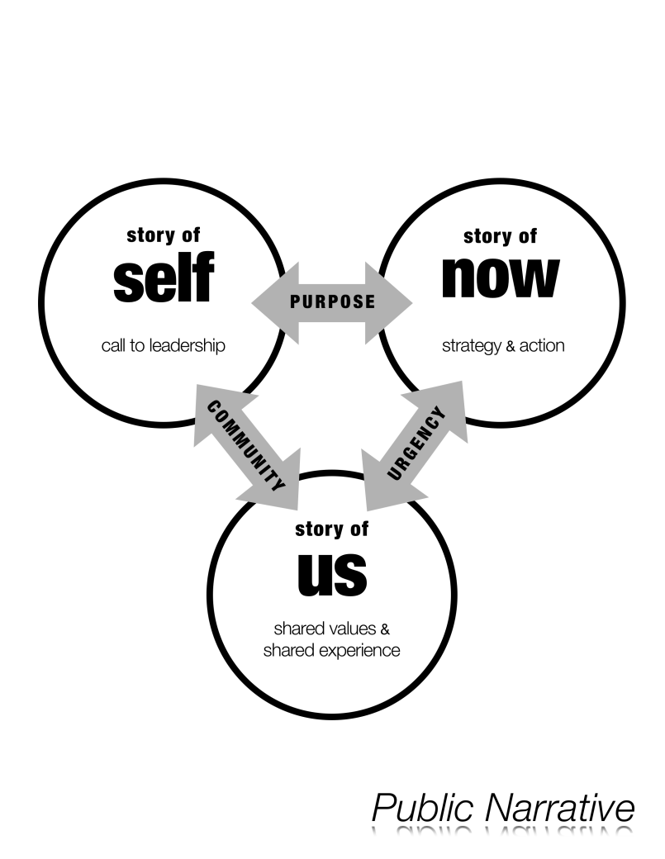
A “story of now” communicates an urgent challenge you are calling on your community to join you in acting on now.
A story of now requires telling stories that bring the urgency of the challenge you face alive – urgent because of a need for change that cannot be denied, urgent because of a moment of opportunity to make change that may not return. At the intersection of the urgency of challenge and the promise of hope is a choice that must be made – to act, or not to act; to act in this way, or in that. The hope resides not somewhere in a distant future but in the sense of possibility in a pathway to action. Telling a good story of now requires the courage of imagination, or as Walter Brueggemann named it, a prophetic imagination, in which you call attention both to the pain of the world and also to the possibility for a better future.
A “story of us” communicates shared values that anchor your community, values that may be at risk, and may also be sources of hope.
We tell more “stories of us” in our daily lives than any other kind of story: “do you remember when” moments at a family dinner, “what about the time that” moments after an exciting athletic event, or simply exchanging stories with friends. Just like any good story, stories of us recount moments when individuals, a group, a community, an organization, a nation experienced a challenge, choice, and outcome, expressive of shared values. The may be founding moments, moments of crisis, of triumph, disaster, of resilience, of humor. The key is to focus on telling specific stories about specific people at specific times that can remind everyone of–or call everyone’s attention to–the values that you share against which challenges in the world can be measured. A “story of us”, however, is “experiential” in that it creates an experience of shared values, rather than “categorical”, described by certain traits, characteristics, or identity markers. Telling a good story of us requires the courage of empathy – to consider the experience of others deeply enough to take a chance of articulating that experience.
A “story of self” communicates the values that called you to lead in this way, in this place, at this time.
Each of us has compelling stories to tell. In some cases, our values have been shaped by choices others – parents, friends, and teachers – have made. And we have chosen how to deal loss, even as we have found access to hope. Our choices have shaped our own life path: we dealt with challenges as children, found our way to a calling, responded to needs, demands, and gifts of others; confronted leadership challenges in places of worship, schools, communities, work.

VIDEO MODEL & REVIEW:
James Croft

Watch this five minute video of James Croft’s Linked Public Narrative. As you watch it, focus on the elements of SELF – US – NOW that you hear in his story.

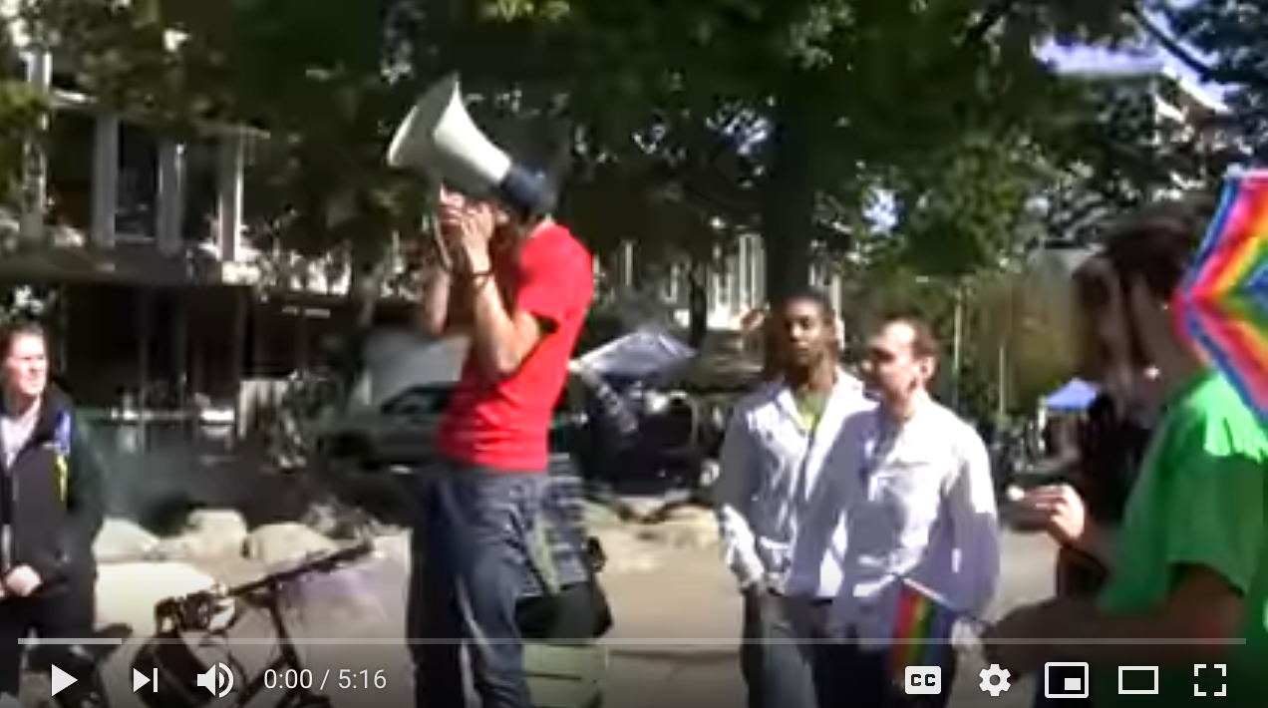
Video Link: James Croft Public Narrative

SELF | US | NOW
What experiences shaped his values? Whose choices were they? Why are they stories? | Who is the “us” to whom he appeals? What moments of choice does he recall? What are the values? | What challenges to those values does he describe? What’s the source of hope? In what action does he ask us to join?

- Why does James Croft begin as he does?

- What challenge, choice, and outcome are at the core of each story he tells?

- What details, images, moments do these stories bring alive?

- What values do these stories communicate?
ADDITIONAL RESOURCES

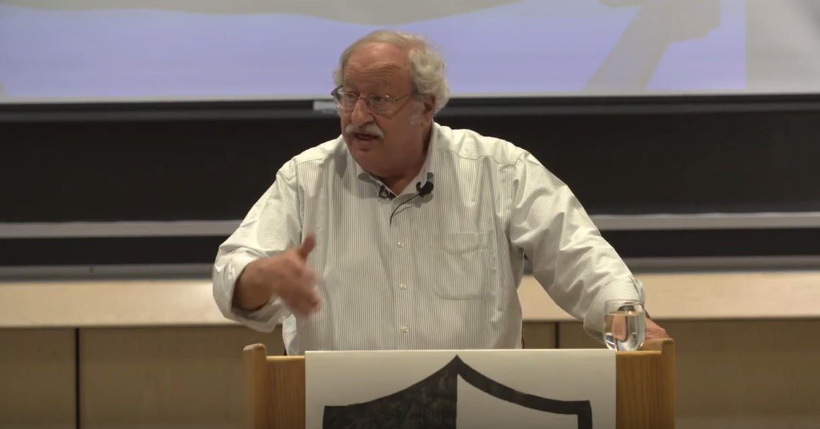
1. Marshall Ganz lecture on Public Narrative and Story of Self

2. Resistance School “Complete Lesson” materials for Public Narrative

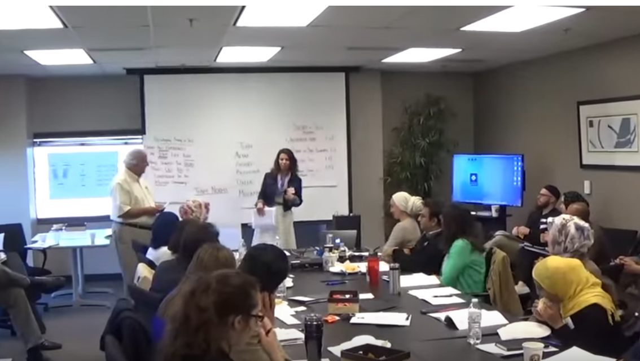
3. Amal Beydoun Story of Self model

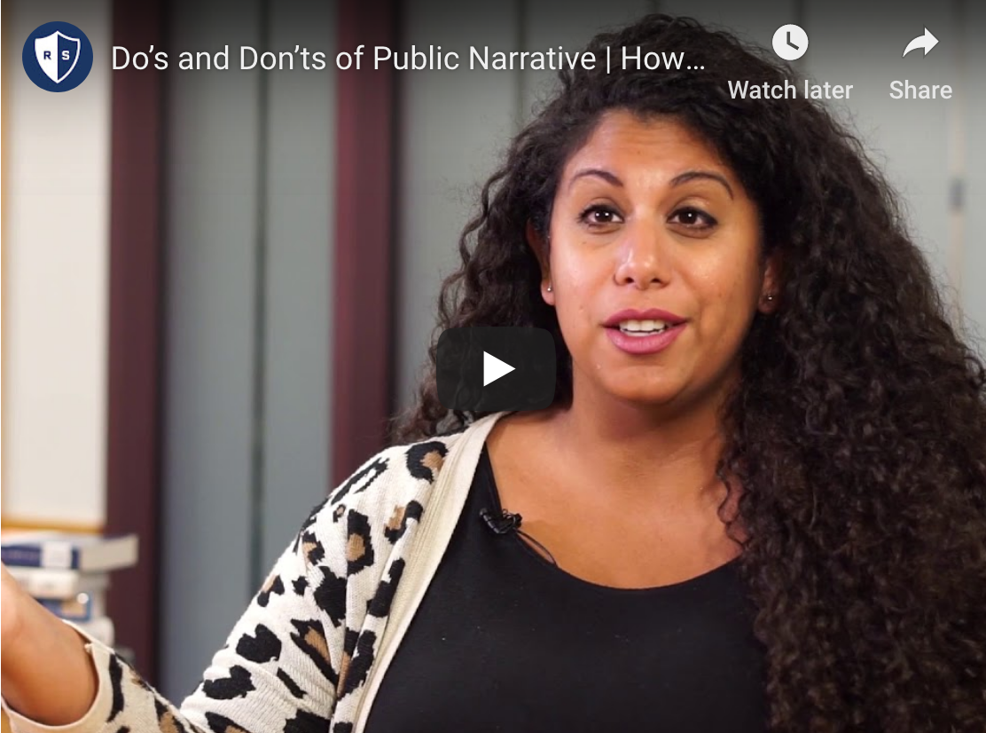
4. Resistance School “Complete Lesson” videos and materials for Coaching Public Narrative
WORKSHEET:
DEVELOPING YOUR STORY OF SELF

Before you decide what part of your story to tell, think about these questions:

- Why am I called to education leadership? Why am I called to the EdLD program?
- What values move me to act? How might they inspire others to similar action?
- What stories can I tell from my own life about specific people or events that would show (rather than tell) how I learned or acted on those values?

What are the experiences in your life that have shaped the values that call you to leadership in education?

FAMILY & CHILDHOOD  Parents/Family  Growing Up Experiences  Your Community  Role Models  School | LIFE CHOICES  School  Career  Partner/Family  Hobbies/Interests/Talents  Experiences Finding Passion  Experiences Overcoming Challenge | ORGANIZING EXPERIENCE  First Experience of organizing  Connection to key books or people  Role Models
Think about the challenge, choice and outcome in your story. The outcome might be what you learned, in addition to what happened. Try drawing pictures here instead of words. Powerful stories leave your listeners with images in their minds that shape their understanding of you and your calling. Remember, articulating the decisions you make in the face of challenges ultimately communicates your values.

CHALLENGE: | CHOICE: | OUTCOME:

For Further Reflection

We all live very rich and complex lives with many challenges, many choices, and many outcomes of both failure and success. That means we can never tell our whole life story in 2 minutes. The challenge is to learn to interpret our life stories as a practice, so that we can teach others based on reflection and interpretation of our own experiences, and choose stories to tell from our own lives based on what’s appropriate in each unique situation.

Take time to reflect on your own public story, beginning with your story of self. You may go back as far as your parents or grandparents, or you may start with your most recent organizing and keep asking yourself why in particular you got involved when you did. Focus on challenges you had to face, the choices you made about how to deal with those challenges, and the satisfactions – or frustrations—you experienced. Why did you make those choices? Why did you do this and not that? Keep asking yourself why.

What did you learn from reflecting on these moments of challenge, choice, and outcome? How do they feel? Do they teach you anything about yourself, about your family, about your peers, your community, your nation, your world around you—about what really matters to you? What about these stories was so intriguing? Which elements offered real perspective into your own life?

What brings you to this campaign? When did you decide to work on improving education, for instance? Why? When did you decide to volunteer? Why? When did you decide to give up a week to come to this workshop? Why?

Many of us active in public leadership have stories of both loss and hope. If we did not have stories of loss, we would not understand that loss is a part of the world; we would have no reason to try to fix it. But we also have stories of hope. Otherwise we wouldn’t be trying to fix it.

A good public story is drawn from the series of choice points that structure the “plot” of your life – the challenges you faced, choices you made, and outcomes you experienced.

Challenge: Why did you feel it was a challenge? What was so challenging about it? Why was it your challenge?

Choice: Why did you make the choice you did? Where did you get the courage – or not? Where did you get the hope – or not? How did it feel?

Outcome: How did the outcome feel? Why did it feel that way? What did it teach you? What do you want to teach us? How do you want us to feel?

COACHING TIPS:
STORY OF SELF

Coach others to develop their Story of Self. Remember to balance both positive and constructive critical feedback. The purpose of coaching is to listen to the way stories are told and think of ways that the storytelling could be improved.

DON’T simply offer vague “feel good” comments. (“That was a really great story!”)
DO coach each other on the following points:

- THE CHALLENGE: What were the specific challenges the storyteller faced? Did the storyteller paint a vivid picture of those challenges?
“When you described ________, I got a clear picture of the challenge.”
“I understood the challenge to be ________. Is that what you intended?”
“The challenge wasn’t clear. How would you describe ________?”

- THE CHOICE: Was there a clear choice that was made in response to each challenge? How did the choice make you feel? (Hopeful? Angry?)
“To me, the choice you made was _______, and it made me feel _______.”
“It would be helpful if you focused on the moment you made a choice.”

- THE OUTCOME: What was the specific outcome that resulted from each choice? What does that outcome teach us?
“I understood the outcome to be _______, and it teaches me _______. But how does it relate to your work now?”

- THE VALUES: Could you identify what this person’s values are and where they came from? How? How did the story make you feel?
“Your story made me feel ________ because _________.”
“It’s clear from your story that you value _______; but it could be even clearer if you told a story about where that value comes from.”

- DETAILS: Were there sections of the story that had especially good details or images (e.g. sights, sounds, smells, or emotions of the moment)?
“The image of ________ really helped me identify with what you were feeling.”
“Try telling more details about _______ so we can imagine what you were experiencing.”
TEAM SESSION:
STORY OF SELF PRACTICE WORK

GOALS
- Practice telling your Story of Self and get constructive feedback
- Learn to draw out and coach the stories of others

AGENDA
TOTAL TIME: 40 min.

 | Gather with your team. Choose a timekeeper and review the agenda. | 5 min.
 | Take some time as individuals to silently develop your “Story of Self.”  Use the worksheet. | 5 min.
 | As a team go around the group and tell your story one by one.  For each person:  - 2 minutes to tell their story  - 3 minutes to offer feedback from the group. Use the preceding coaching tips to ask your teammates helpful coaching questions. Use the following worksheet to write down your feedback and track the narrative elements in your teammates’ stories.  NOTE: You have just 2 minutes to tell your story. Stick to this limit. Make sure your timekeeper cuts you off. This encourages focus and makes sure everyone has a chance to tell their story. | 25 min.

Record Feedback/Comments from Your Team Members Here:

Coaching Your Team's “Story of Self’: As you hear each other's stories, keeping track of the details of each person’s story will help you to provide feedback and remember details about people on your team later. Use the grid below to track your team's stories in words or images.

NAME | VALUES | CHALLENGE | CHOICE | OUTCOME

CREATING SHARED COMMITMENT:
BUILDING POWER THROUGH RELATIONSHIPS

To whom am I committed?

BUILDING POWER THROUGH RELATIONSHIPS

Why Build Relationships? Organizing vs. Mobilizing
Goals for this section:

To learn how to build relationships to develop leadership, community and power

To practice building intentional relationships through the skill of one-to-one organizing conversations

To identify common values, interests, and resources amongst the team

Leadership begins with understanding yourself: your values, your motivation, your story. But leadership is about enabling others to achieve purpose. The foundation of this kind of leadership is the relationships built with others, most especially, others with whom we can share leadership.

Leadership in organizing is based on relationships. This is a key difference between mobilizing and organizing. When we mobilize we access and deploy a person’s resources, for example, their time to show up at a rally, their ability to “click” to sign a petition (or their signature), of their money. But when we organize we are actually building new relationships which, in turn, can become a source not only of a particular resource, but of leadership, commitment, imagination, and, of course, more relationships. In mobilizing, the “moment of truth” is when we ask, can I count on you to be there, give me $5.00, and sign the petition. In organizing the “moment of truth” is when two people have learned enough about each other’s interests, resources, and values not only to make an “exchange” but also to commit to working together on behalf of a common purpose. Those commitments, in turn, can generate new teams, new networks, and new organizations that, in turn, can mobilize resources over and over and over again.

- Identifying, Recruiting, and Developing Leadership: We build relationships with potential collaborators to explore values, learn about resources, discern common purpose, and find others with whom leadership responsibility can be shared.

- Building Community: Leaders, in turn, continually reach out to others, form relationships with them, expand the circle of support, grow more resources that they can access, and recruit people who, in turn, can become leaders themselves.

- Turning Resources into Power: Relationship building doesn’t end when action starts. Commitment is how to access resources for organizing – especially when you come up against competition, internal conflict, or external obstacles. Commitment is based on relationships, which must be constantly, intentionally nurtured. The more others find purpose in joining with you the more they will commit resources that you may never have known they had.
Coercion or Commitment?

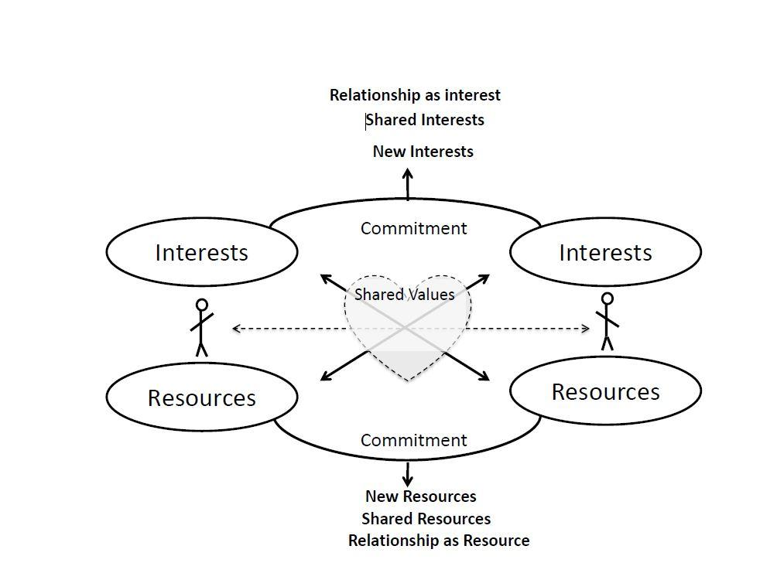
Leaders must decide how to lead their organization or campaign. Will the glue that holds things together be a command and control model based on coercion? Or will the glue be volunteered commitment? If our long-term power and potential for growth comes more from voluntary commitment, then we need to invest significant time and intentionality in building the relationships that generate that commitment—to each other and to the goals that bring us together. That requires transparent, open and mindful interaction, not closed, reactive or manipulating maneuvers.

What Are Relationships?

- Relationships are rooted in shared values. We can identify values that we share by learning each other’s stories, especially ‘choice points’ in our life journeys. The key is asking “why.”

- Relationships grow out of exchanges of interests and resources. Your resources can address my interests; my resources can address your interests. The key is identifying interests and resources. This means that relationships are driven as much by difference as by commonality. Our common interest may be as narrow as supporting each other in pursuit of our individual interest, provided they are not in conflict. Organizing relationships are not simply transactional. We’re not simply looking for someone to meet our “ask” at the end of a one-to-one meeting or house meeting. We’re looking for people to join with us in long-term learning, growth and action.

- Relationships are created by commitment. An exchange becomes a relationship only when each party commits a portion of their most valuable resource to it: time. A commitment of time to the relationship gives it a future and, therefore, a past. And because we can all learn, grow, and change, the purposes that led us to form the relationship may change as well, offering possibilities for enriched exchange. In fact the relationship itself may become a valued resource – what Robert Putnam calls “social capital.”

- Relationships involve constant attention and work. When nurtured over time, relationships become an important source of continual learning and development for the individuals and communities that make up your campaign. They are also a great source for sustaining motivation and inspiration.

Building Intentional Relationships: The One-on-One Meeting.

One way to initiate intentional relationships is the one-on-one meeting, a technique developed by organizers over many years. A one-on-one meeting consists of five “acts”:

Attention – We have to get another person’s attention to conduct a one-on-one meeting. Don’t be “coy”. Be as up front as you can be about what your interest is in the meeting, but that first, you’d like it take a few moments to get acquainted.

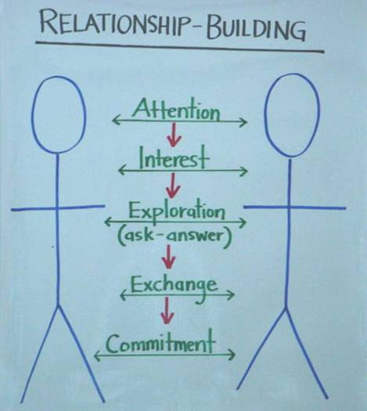
Interest – There must be a purpose or a goal in setting up a one-on-one meeting. It could range from, “I’m starting a new network and thought you might be interested” to “I’m struggling with a problem and I think you could help” or “I know you have an interest in X so I’d like to discuss that with you.”

Exploration – Most of the one-on-one is devoted to exploration by asking probing questions to learn the other person’s values, interests, and resources and by sharing enough of your own values, interests, and resources that it can be a two-way street.

Exchange – We exchange resources in the meeting such as information, support, and insight. This creates the foundation for future exchanges.

Commitment –A successful one on one meeting ends with a commitment, most likely to meet again. By scheduling a specific time for this meeting, you make it a real commitment. The goal of the one-on-one is not to get someone to make a pledge, to give money, to commit his or her vote as it is to commit to continuing the relationship.

DO | DON’T
Schedule a time to have this conversation (usually 30 to 60 minutes) | Be unclear about purpose and length of conversation
Plan to listen and ask questions | Try to persuade rather than listen and ask questions
Follow the steps of the conversation above | Chit chat about private interests
Share experiences and deep motivations | Skip stories to “get to the point”
Share a vision that articulates a shared set of interests for change | Miss the opportunity to share ideas about how things can change
Be clear about the ‘when and what’ of your next step together. | End the conversation without a clear plan for the next steps.

VIDEO MODEL & REVIEW:
ANJALI & JEFF

Watch this model video of a 1-1 between Anjali and Jeff. Use the following reflection questions to deepen your understanding of 1-1 meetings and plan how to have your own intentional 1-1 meetings. As you watch it, focus on the the questions that Anjali asks to uncover Jeff’s interests, values, and resources. Also notice what she offers of her own story to build the relationship.

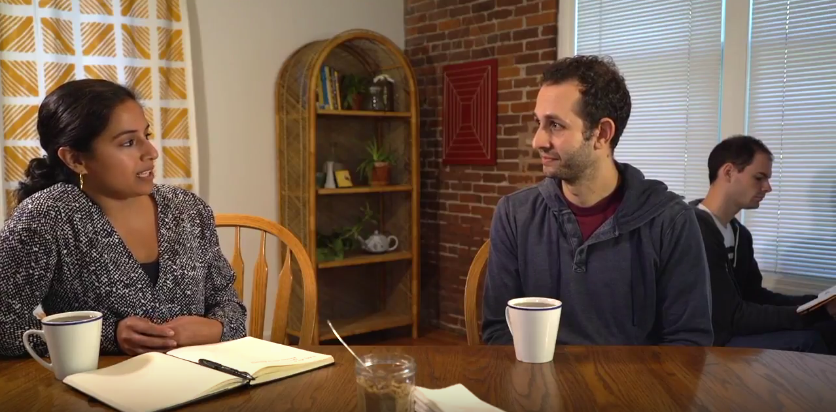

Video Links: 1-1 model video

Reflection Questions:
- What does Anjali say to clarify her interest in meeting with Jeff? Is her actual reason for meeting him a secret that she surprises him with at the end, or is she transparent about it early on?
- In the “exploration” part of the 1-1, what questions does Anjali ask to uncover Jeff’s interests and values? What does she offer of her own story? How does exploring each others stories, interests, values help to build the relationship?
- What resources (skills, materials, networks, languages, etc) are uncovered in this 1-1? What questions or comments helped to uncover resources? How could uncovering resources in this case be valuable for building power in the campaign?
- What commitment does Anjali ask for? Why did she choose that instead of making a different “ask”?
- What commitments will you ask for

ADDITIONAL RESOURCES

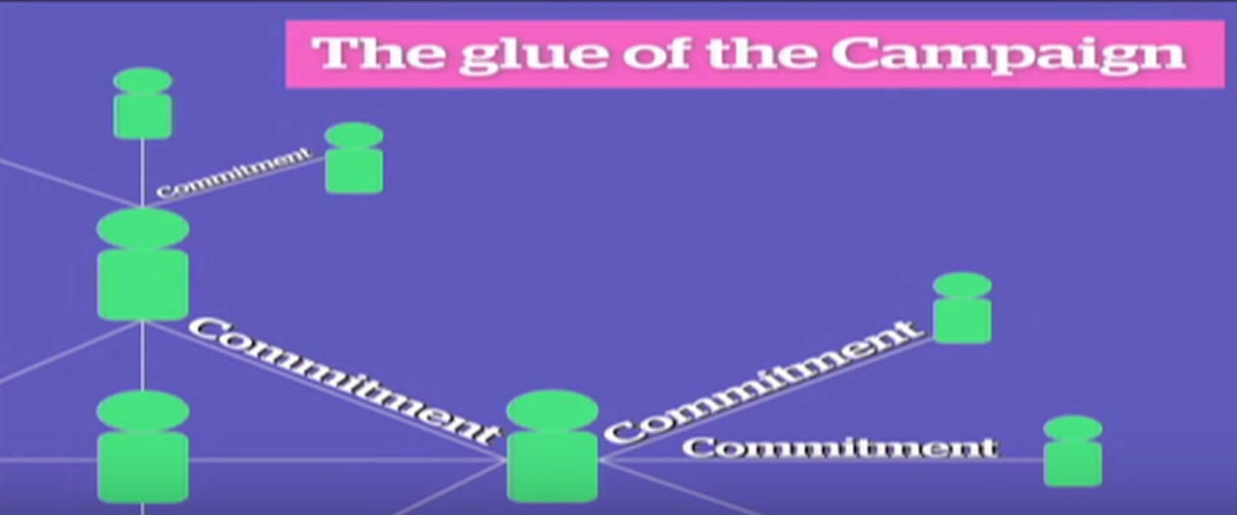
1. Video: Training by Joy Cushman at New Organizing Institute
2. Video: Obama campaign South Carolina house meetings
3. Video: Obama campaign reflections on house meetings
4. Video: Ernesto Cortes on relational meetings
5. Resistance School complete lesson on “How to Build Relationships”

TEAM BREAKOUT SESSION: ONE-ON-ONES
PRACTICE BUILDING RELATIONSHIPS

Goals
- Practice the art of the 1-on-1 conversation by using probing questions to discern shared values based on learning each other’s stories, to identify each other’s interests, and to discover resources that could address those interests.
- Discern values your team shares, interests it has in common, and resources at its disposal.

AGENDA
TOTAL TIME: 45 min.
1. | Gather in your team. Choose a timekeeper and note-taker. Review the agenda below. | 3 min.
2. | Break into pairs. Practice a one-on-one:  8 min.  The organizer builds a relationship with the organizee. Ask questions but don’t make it an interview! Share your life too. Don’t extract information; build a relationships while focusing on drawing out common values, shared interests and potential resources that can support your team’s campaign. Make a clear ask that is related to your team’s campaign.  2 min.  The organizee provides feedback for the organizer. How did you feel? Did you feel “networked” or manipulated? Or did you feel that the organizer was actually building a relationship with you? What did the organizer do well? How can the organizer improve?  After 10 minutes switch roles  Listen carefully and write these down for later:  - Your common values  - Your shared interests  - Your skills and resources  Make a specific commitment to each other. | 20 min.
3. | Get to know your team. | 20 min.
Each pair reports back on the following three questions:
- What did you learn about values that you share?
- What did you learn about common motivating interests you may have?
- What did you learn about the resources of your partner that can support your project?
Ask your note-taker to record these on flipchart paper for your whole team like this:
Our Common Values | Our Shared Interests | Our Unique Resources

4. | Summarize your key learning’s from this exercise. What are you taking away? Select someone to report to the larger group. Rejoin the larger group. | 2 min.

WORKSHEET:
PRACTICE RELATIONSHIP BUILDING

ONE-ON-ONE PRACTICE (20 min)

Choose a partner you don’t know well. Learn about why she/he has been called to do this work. Probe with “why?” questions to get to choice points and specific experiences that shaped her/his life. Share your story. Listen to your partner’s story for the motivations and the resources she brings to the campaign (leadership skills, a following, action skills, etc.). Be specific.

Avoid talking about issues like justice in an abstract and detached way — get to the lived experience of why you care about the specifics that you want to do something about. What values were you taught that make you care about this? How did you learn these values? From whom?
Hope: What motivates you to act to organize others? What’s your vision of how things could be different if we work together?

_________________
_________________

Story: What’s your family story? What in your life brought you here today?

_________________
_________________

Leadership Resources: What skills do you have? How do you lead others already in your life? What would you be willing to bring to this movement?

_________________
_________________

Challenges: What keeps you from action? What do you fear? What would you want to learn?

_________________
_________________

What values do we share?
What interests can we act on together?
What skills and resources do we each bring to this work?
When will we meet again to take action and to keep building this relationship?

FURTHER REFLECTION QUESTIONS:

1. How does this way of doing one-to-ones compare with other types of conversations you have? How is it different from an interview? How is it different from a sales pitch?

2. What was most challenging about that exercise?

3. How could this type of relationship-building (either through one-on-ones or at house meetings or meetings) be used in organizing in your community and cause?

PLANNING QUESTIONS:

1. How many 1-1 meetings will you have each week? How many people will you invite to a 1-1 in order to achieve your goal (note: not everyone you ask will actually meet with you)?

2. What relational strategies and tactics will you use in your project?

3. What kinds of commitments are you seeking through relationships in your project? How do you go about asking for commitments? How do you know when you have a real commitment?

CREATING SHARED STRUCTURE:
BUILDING LEADERSHIP TEAMS

What is our purpose and what are our norms and roles?

BUILDING LEADERSHIP TEAMS
Goals for this section:

To develop an understanding of the core practices of successful leadership teams

To practice those skills by developing a shared purpose, clarifying
team roles and responsibilities, and creating norms and practices of coordination

Why do leadership teams matter?

Most effective leaders create teams to work with them and to lead with them. Take for example Moses, Aaron and Miriam in the story of Exodus, or Jesus and the twelve disciples in the New Testament, or Martin Luther King, Ralph Abernathy, Rosa Parks, Jo Ann Robinson and E D Nixon during the Montgomery Bus Boycott.

A leadership team offers a structured way to work together interdependently, each person taking leadership on during part of the team’s activity. At their best leadership teams recognize and put to productive use the unique talents of the individuals who make up the team.

Team structures also help create strategic capacity—the ability to strategize creatively together in ways that produce more vibrant, engaging strategy than any individual could create alone. In the Obama campaign, the field structure created multiple layers of leadership teams to engage people creatively and strategically at all levels of the campaign. Each state had a state leadership team that coordinated regional leadership teams (of Regional Directors and Organizers), which coordinated local neighborhood leadership teams of volunteer leaders.

At every level the people on leadership teams had a clear mission with clear goals and the ability to strategize creatively together about how to carry out their mission and meet their goals. This structure created multiple points of entry for volunteers, and multiple opportunities to learn and to exercise leadership.

Leadership teams provide a foundation from which an organization can expand its reach. Once a team is formed, systems can be created to establish a rhythm of regular meetings, clear decisions and visible accountability, increasing the organization’s effectiveness. One person alone cannot organize 500 people. It is built by finding people willing and able to commit to helping build it, and creating relationships and a solid structure from which it can be built.

So why don’t people always work in teams?

We have all been part of volunteer teams that have not worked well. They fall into factions, they alienate each other, or all the work falls on one person. Some aim to keep the pond small so they can feel like big fish. So many of us come to the conclusion: I’ll just do it on my own; I hate meetings, just tell me what to do; I don’t want any responsibility; just give me stamps to lick. There’s just one problem: we can’t become powerful enough to do what we need to do if we can’t even work together to build campaigns we can take action on.

The challenge is to create conditions for our leadership teams that are more likely to generate successful collaboration and strategic action. When groups of people come together, conflict is always present. Effective teams are structured in a way to channel that conflict in productive ways, allowing the team to achieve the goals it needs to win.

Three measures of an effective team:

    - OUTPUT (WORLD): The success of your team in taking the action required to achieve its valued goals – winning the game, winning the campaign, putting on the play, etc.

    - CAPACITY (TEAM): Over time your team is learning how to work more effectively as a team, and developing more leadership.

    - LEADERSHIP DEVELOPMENT (INDIVIDUAL): Individuals who participate on your team learn and grow as a result of their participation.

Three conditions that make for a “real” team.

Your team is bounded. You can name the people on it; they don’t come and go, whoever shows up doesn’t have the automatic right to participate in the team. Most highly effective teams have no more than 4 - 8 members.

Your team is stable. It meets regularly. It’s not a different, random group of people every time. Membership of the team remains constant long enough that the team learns to work together better and better; each member is fully committed to be on the team and commits consistent time and effort to it.
Your team is interdependent. As on an athletic team, a string quartet, or an airplane cabin crew, the contribution that each person makes is critical to the success of the whole. Team members have a vital interest in each other’s success, looking for ways to offer support.

Three steps to launching an effective team: purpose, ground rules, and roles.

You have a shared – and engaging –purpose. You are clear on what you have created your team to do (purpose), who you will be doing it with (constituency), and what kinds of activities your team will participate in. The work you have to do is readily understood, it’s challenging, it matters and you know why it matters. Team members need to be able to articulate for themselves and others this "purpose".

You have created clear interdependent roles. Each team member must have their own responsibility, their own “chunk” of the work, on which the success of the whole depends. No one is carrying out activity in a silo that’s secretive to others. A good team will have a diversity of identities, experiences and opinions, ensuring that everyone is bringing the most possible to the table.

Your team has explicit ground rules. Your team sets clear expectations for how to govern itself in your work together. How will you manage meetings, regular communication, decisions, and commitments? And, most importantly, how will you correct ground-rule violations so they remain real ground rules? Teams with explicit operating rules are more likely to achieve their goals. Some team norms are operational, such as how often will we meet? How will we share and store documents? Communicate with others outside the team? etc. Others address expectations for member interaction with each other. Initial norms guide your team in its early stages as members learn how to work together. Norms can be refined through regular group review of how well the team is doing.

ADDITIONAL RESOURCES FOR BUILDING LEADERSHIP TEAMS

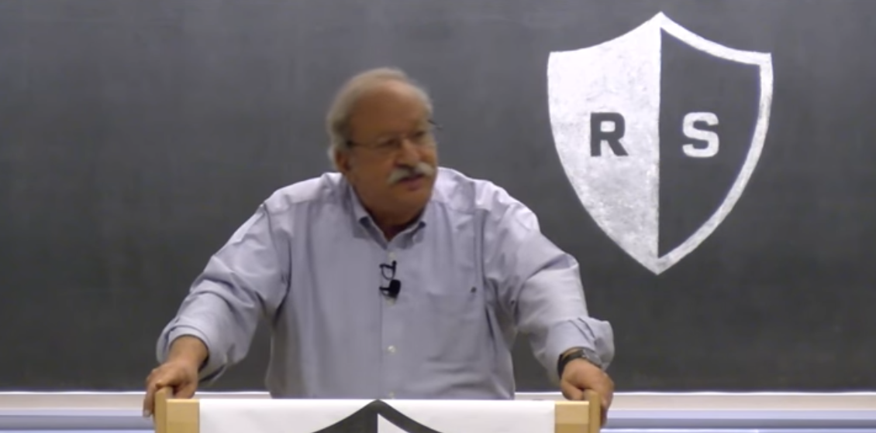

- Video: Resistance School training by Marshall Ganz on How to Build a Leadership Team
- Resistance School “Complete Lesson” on How to Build Leadership Teams, including three readings
- Video: Jeremy Bird: Scaling Grassroots Movements with the Obama Campaign

TEAM BREAKOUT SESSION:
BUILDING YOUR TEAM

Goals
- Decide on a context for the workshop, based on your pre-written proposals.
- Develop your team purpose.
- Identify the norms you will practice as a team, including a decision-making norm.
- Define your leadership roles. Then discuss the roles relative to the talents of those in your team.

AGENDA
TOTAL TIME: 90 min.
1. | Gather and review agenda. Choose a timekeeper for this session. |  | 2 min.
2. | Develop your shared purpose using the model video and worksheet that follow. Review your shared interests from the last session, and focus on how you as a team will work together on your campaign. | 40 min.
3. | Decide on collaborative norms that will enable you to function with shared commitment. Use the model video and worksheet that follow. |  | 20 min.
4. | Determine team roles. Brainstorm possible responsibilities as you work together beyond this workshop. For example, who will coordinate the meetings? Talk about how these roles might match up with the talents of those on your team. Use the model video and worksheet that follow. |  | 20 min.
5. | Determine your team name & chant using the video and worksheet that follow. |  | 8 min.

WORKSHEET:
DEVELOPING SHARED PURPOSE

SHARED PURPOSE (40 minutes)
Watch the support video: Developing a Shared Purpose

There are four parts to this exercise. In the first part, as individuals, you will take 5 minutes to clarify your own thinking about what the purpose of your team could be as you work on a campaign together. In the second part, as a team, you will take 10 minutes to share your ideas, look for the common focus, and discern a purpose you can all support. You then have 5 more minutes to write a new sentence that you think captures the sense of your team. And finally, as a team, you will have 5 more minutes to consider the second round of sentences and decide on one that best articulates your team’s perspective.

Part I: Individual Work (5 minutes)

- In the first column, based on the work you did on common interests and values in the relationship session, write down the unique goal or goals of your team.

- In the second column, write down whom your team serves: What are the people like and what are their interests?

- In the third column, write down the kinds of activities that your team could engage in to fulfill its purpose by serving this community? What is the unique work that your team could do?
Our team’s shared purpose is to (briefly describe your team’s unique reason for coming together) | The constituency we organize is  (briefly describe your constituency’s characteristics) | We will achieve our shared purpose by  (list the specific activities that your team would undertake.)

After brainstorming answers to all three questions, take a few moments to write a sentence that you think best describes your team’s purpose, it’s constituency, and its activities. Draw on all three columns above.

Examples of a shared purpose sentence:

We share the purpose of educational equity by organizing Boston students to create their own advocacy organization by providing them with coaching, training, and mentoring

Our team’s shared purpose is to

Part 2: Team Work (10 minutes)
As each person reads his or her sentence, the facilitator notes the key words on flipchart paper under purpose, constituency, or work. Note specific words to which you respond, that spark your curiosity, or that give you energy. When you are done, your facilitator circles the words that seem to resonate most strongly with your team.
Part 3: Individual Work (5 minutes)
In light of what you learned from the last session, write a new sentence that you think can articulate a shared purpose, using some of the key words and themes.
Our team’s shared purpose is to

Part 4: Team Work (5 minutes) We will read our sentences again and choose – or combine – one that can best articulate the shared sense of your team.

WORKSHEET:
DEVELOPING TEAM NORMS
Watch the support video: Developing Norms

TEAM NORMS/EXPECTATIONS (20 minutes)
Review the sample team norms below. Add, subtract or modify to create norms for your team. Be sure to include group norms on each theme below and how you will self correct if the norm is broken. (If you don’t self correct, the new norm will be breaking the norms.)

Decision-making: What is the process by which we will make decisions?
- Majority rules: Whatever gets the most votes wins.
- Consensus: Everyone must agree.
- Delegation: Nominate one or two people on your team to be the ultimate decision-makers.
- Coin flip: Leave the decision to fate!
- Other:
Discussion and Decision-making: How we will discuss options and reach decisions as a team to ensure vigorous input and debate?
Always Do  Engage in open, honest debate  Ask open-ended questions  Balance advocacy with inquiry | Never Do  Engage in personal attacks  Fail to listen to what others say  Jump to conclusions
Meeting Management: How will we manage meetings to respect each other’s time?
Always Do  Start on time; stay on time  Be fully present throughout the meeting | Never Do  Come to meetings unprepared  Answer cell phones or do email
Accountability: How we will delegate responsibilities for actions and activities? How will we follow through on commitments?
Always Do  Clarify understanding  Provide follow-up on action items  Ask for/offer support when there is a need  Weekly check-in | Never Do  Assume you have agreement  Assume tasks are getting done  Commit to a task that you know you  won’t do
How will you “self correct” if norms are not followed?
**Teams work best when you have a regular, reliable time to coordinate together. What will your team’s regular meeting time and place be?

WORKSHEET:
DEVELOPING TEAM ROLES
Watch the support video: Determining Roles

Understanding Team Roles (20 min.): Review the Team Coordinator role below as an example of what roles might look like in your individual campaigns. Thinking about how you should organize the next event/meeting, discuss how your roles would fit together to create an interdependent leadership team that supports one another in your individual projects. What would each role have to be good at? Based on the discussion about the roles, go around the circle and ask each person to tell others: 1) what experience and talents they have that might contribute to the leadership team and 2) what specifically they want to learn in more detail (30 seconds each). How might these talents match up to particular roles? Are there any clear “fits”?
Note: These team roles should not be seen as permanent. For the team to be strong, all leaders should have to earn leadership by carrying out responsibilities relevant to the role they seek.
Role | Responsibilities | You would be good for this role if you . . . | Interested Team members & Related Skills/Talents
Team Coordinator | Coordinate the work of the leadership team. Prepare for meetings, give support and coaching to the team.

TEAM NAME and CHANT (8 minutes)
Watch the support video: Determining Team Name & Chant (Team Identity)

TEAM ROSTER

NAME PHONE EMAIL ADDRESS

PUBLIC NARRATIVE:
STORY OF US

Who is this community and what are we called to do?

Goals for this section:

To learn how to tell the story of our community in a way that reflects our shared values, hopes, and experiences

Each participant practices telling a Story of Us and gets feedback on their story
INTRODUCTION TO STORY OF US

What is a Story of Us?
You tell a story of self to enable others to “get you” – to experience the values that call you to public life. You tell a “story of us” to enable them to “get each other”- to experience the values they share that can inspire them to act together, find courage in each other, and find hope in their solidarity. In other words, the “us” that the storyteller brings alive is based less on what “category” describes them (race, gender, language, etc.), a “categorical us”, than values the share rooted in common experience, an “experiential us.” By learning to tell a story of us you can bring those values alive as a source of solidarity, hope, and the motivation to act.

Crafting a Story of Us.

One way people develop their sense of “usness” is by sharing stories that celebrate values they share. They may share stories of family, community, faith tradition, school life, profession, movements, organizational happenings, national experience, generational moments, cultural events, or even global occurrences. But, as stories, they’re about our experience of these moments, challenges we faced, obstacles we overcame, or didn’t, values we tested, or that tested us, and lessons we learned that made us who we are.

The character in the story of us is the people you are motivating to act.

Our story of self is interwoven with stories we share with others through communities we are a part of, which have stories of their own. These include stories of our family, community, faith tradition, school, profession, movements, organizations, nations and, perhaps world. It is through shared stories that we establish the identities and express the values of the communities in which we participate (family, faith, nation) and of new communities we are forming (new social movements, new organizations, new neighborhoods).

Telling a “story of us” requires learning how to put into narrative form experiences the “us” in the room share, that “lift up” the values on which you will be challenging them to act. This story of us may well reach beyond the people in the room, drawing in a wider range of experience, and larger stories of us, but to be effective it must be rooted in the experience of the people in the room.

The Story of Us in the Room

Although the reach of a story of us may extend far beyond “people in the room” it becomes real only in the experience of the “people in the room” – or not. The test is simple. As we heard this story did we begin to feel like an us? The experience of shared values may grow out of stories of historic moments we remember, or have heard of; they might be stories of life events like having children, stories of finding out you were accepted to this program; stories of what happened the first time you met, or last night, or this morning. And, like all stories, the more detailed, the more specific, and he more visual they are, the more effective they will be. What were the names of the people involved? What did they look like? How were they different? Sometimes stories of us emphasize obvious differences in race, religion, gender, age, for example, may actually highlight commonality of values or common purpose.

Linking Story of Self and Story of Us

A story of self tells people who you are and why you are called to do the work that you are doing. The goal is for them to “get you”, to connect with you. Since organizing is about building power with others for shared action, your public narrative also needs to tell a story of the values shared by those whom you hope to move to collective action. The test of a story of us is whether or not they “get” their connection with each other.

Narrative Structure: Challenge, Choice, Outcome
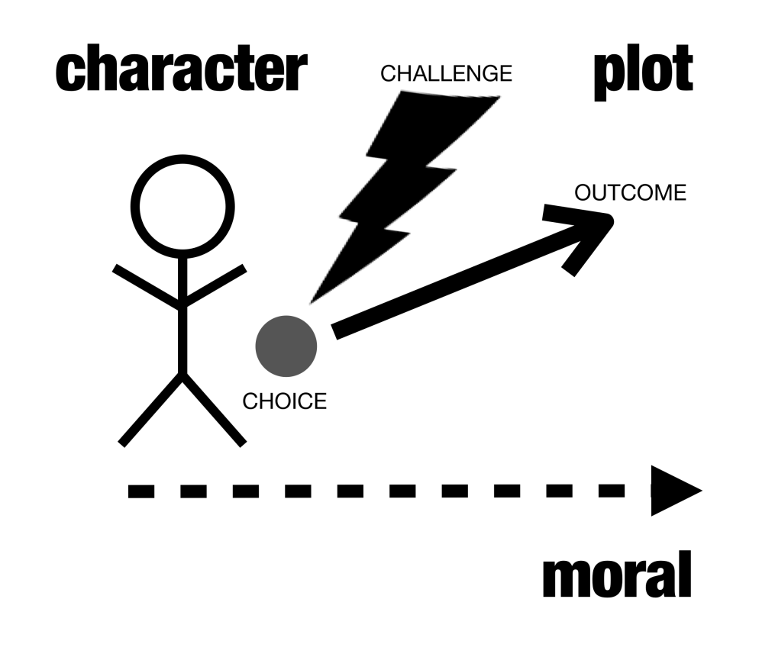
Remember the story structure we introduced in telling your Story of Self?

Just like in your Story of Self, your Story of Us has a clear challenge, choice and outcome:

The Challenge: The challenges your community has faced in the past, or faces now (made real with stories, images, and details, not statistics).

The Outcome (hope): Stories with vivid images that remind your community of what you’ve achieved. Your own experiences of hope, experiences that point to your future.

The Choice: For a story to be a story, it centers on a “choice”. In a story of us, that choice is one that met challenge with action, and thus can be a source of hope. Founding stories recount choices made by those who initiated the community, enabling us to experience the values that motivated them. Choices made by people in the course of the workshop – to take risks, to be open to learning, etc. – can become part of the ‘story of us” of the workshop.

Stories of us can begin to shift power relationships by building new community and new capacity

Often after we’ve heard others’ stories of self and we’ve started building relationships together we discover that we face similar challenges that are rooted in very deep systems of power inequality. Learning to tell stories of Us is a way to begin to join our stories together and acknowledge those shared challenges and the roots of the problem as a community. However a good story of us doesn’t just convey the root of our challenges, but also lifts up our heroes, and stories of even small successes. Those stories give us hope that if we come together and take action as a community we can uproot some of the underlying causes of our suffering.

VIDEO MODEL & REVIEW:
SUSAN CHRISTOPHER

Watch the 3 minutes of Susan Christopher’s Story of Us. As you watch it, focus on the elements of the Story of Us that you hear in her story.

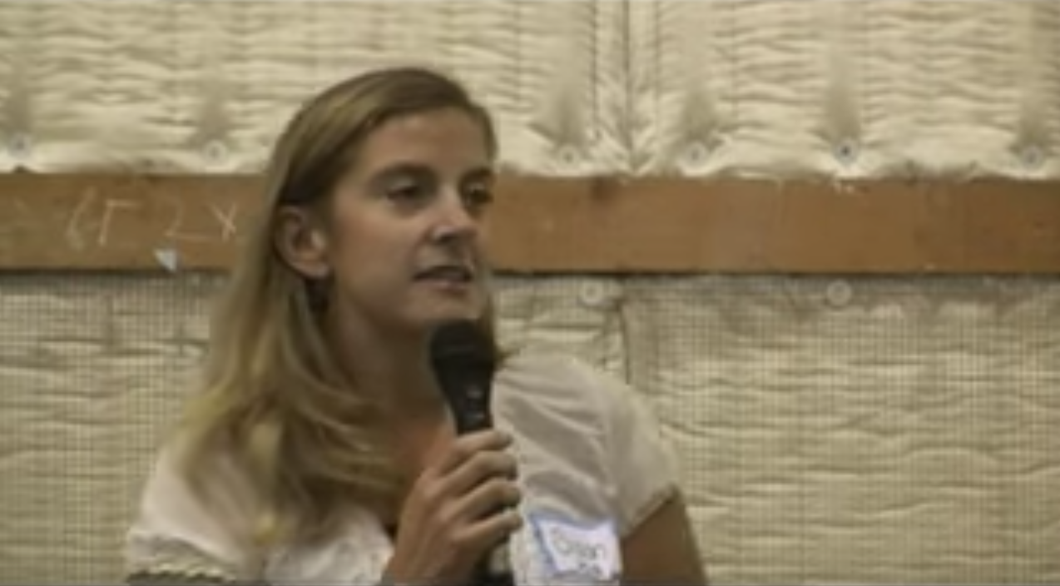
Model video link: Susan Christopher Story of Us

CHALLENGE | CHOICE | OUTCOME
Who is the “us” to whom she appeals? How does she articulate the group’s challenge? What images does she create? | What moments of choice does she recall? What are the values? | Where does she locate the source of hope? What is the outcome of the community’s choices?

- Why does Susan Christopher begin as she does?

- What challenge, choice, and outcome are at the core of the story she tells?

- What details, images, moments does her story bring alive?

- What values does her story communicate?

ADDITIONAL RESOURCES FOR STORY OF US
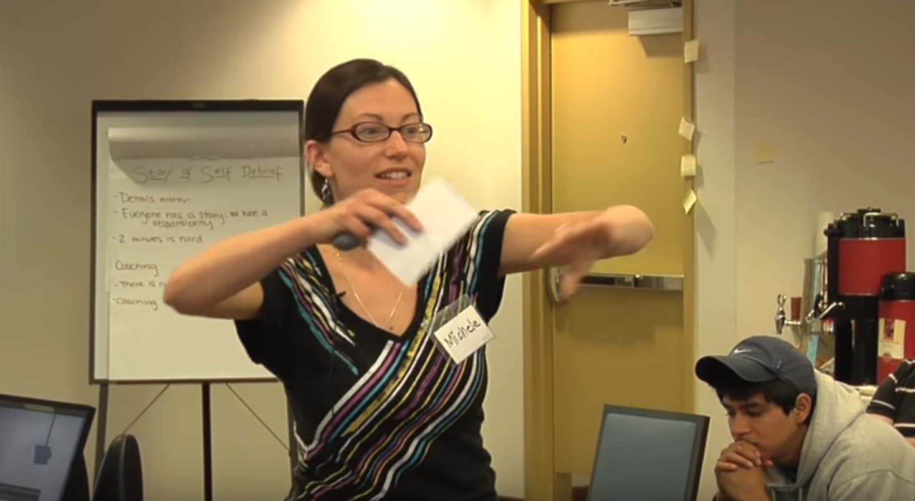
1. Video: Story of Us & Now training by Michelle Rudy at New Organizing Institute
TEAM BREAKOUT SESSION:
STORY OF US PRACTICE

Goals
- Develop a Story of Us. Learn how to communicate the core values of the community you’re building that can inspire others to identify with each other in common action.
- Coach others’ stories by listening carefully, offering feedback, and asking questions.

AGENDA
TOTAL TIME: 40 min.

 | - Gather in your team. Nominate one person to be a timekeeper. | 2 min.
 | - Take some time as a group to brainstorm the “Us.” Use the worksheet that follows.  - Take some time as individuals to silently develop your Story of Us. How does your story relate to the story of your peers in this program? What shared values do they evoke? Use the worksheet that follows. | 5 min.  5 min.
 | - As a team, go around the group and tell your story one-by-one. Use the worksheet that follows as scratch paper for your feedback.  - 2 minutes to tell your Story of Us  - 3 minutes to receive feedback from the group | 25 min.

WORKSHEET:
DEVELOPING YOUR STORY OF US

The purpose of the story of us is to create a sense of community among individuals who may or may not yet see themselves as a community and to give them hope that they can make a difference. It builds on shared experiences and outcomes of previous actions to establish the context in which to take future action. Your goal here is to tell a story that evokes our shared values as your audience, and shows why we in particular are called to take responsibility for action now.

Your story of us may be a story of what we’ve already done together (common experiences), challenges we’ve already faced and outcomes we’ve achieved. Or it may be a story of some of our shared heroes, challenges they faced and outcomes they’ve achieved. Hearing how we’ve met challenges in the past gives us hope that we can face new challenges together.

Brainstorm all the stories you know of about your audience and your collective story and experience. Your story of us may change each time you are talking to a different group of people as you create new community with them.
As a GROUP, brainstorm through the following questions (5 min):
What meaningful experiences have individuals in the room shared? These should be events (not characteristics) that your group could feel connected with, whether they occurred before or during this workshop.

Which specific shared experiences of this community express those values? These should be events (not characteristics) from before or during the time that this group has been together.

What are the challenges in these stories?

What are the sources of hope in these stories?

Individual Work
Now, on your own, choose a few of the stories you brainstormed above to flesh out in vivid detail. Remember, you can use this space to draw pictures instead of writing words, to help you think about where to add detail and nuance in your story. (5 min.)

CHALLENGE  What was the challenge we faced? What’s the root of that challenge? | CHOICE  What specific choice did we make? What action did we take? | OUTCOME  What happened as a result of our choice? What hope can it give us?

EACH STORY TELLER SHOULD:

- SELF – Start your story in a couple of sentences (Examples of sentences that could create the space for an US- I care about because of my own lived experience, before I came here, I thought I was alone)
- US – TAKE TWO MINUTES to tell your story of US as it relates to the people you are talking with that connects to your shared values. Create the space for an ASK by evoking a shared value, experience, urgency

COACHING TIPS:
STORY OF US

Remember to start with positive feedback FIRST and then move into what could be improved. Focus on asking questions instead of giving advice. The purpose is to coach, not judge or criticize; listen fully to offer ways that the storytelling could be improved.

Coaching Questions

- INTERWEAVING SELF AND US: Did the story of self relate to the story of us? If so, what was the common thread?

- THE US: Who is the “us” in the story? Do you feel included in the “us”?

“Could you focus more on the experiences we as a small group shared today that reflect our values? For instance, .”

- THE CHALLENGE: What were the specific challenges the storyteller faced? How were those challenges made vivid?
“I understood the challenge to be ________. Is that what you intended?”

- THE CHOICE: Was there a clear choice that was made in response to each challenge? How did the choice make you feel? (Hopeful? Angry?)
“To me, the choice you made was _______, and it made me feel _______.”

- THE OUTCOME: What was the specific outcome that resulted from each choice? What does that outcome teach us?
“I understood the outcome to be _______, and it taught me _______.”

- THE VALUES: Could you identify what this community’s values are and how this community has acted on those values in the past? How?
“Your story made me see that we value ________ because _________.”

- DETAILS: Were there sections of the story that had especially good details or images (e.g. sights, sounds, smells, or emotions of the moment)?
“The image of ________ really helped me feel what you were feeling.”

WORKSHEET:
COACHING YOUR TEAMMATES’ STORIES OF US

Record Feedback/Comments from Your Team Members On Your Story Here:

Coaching Your Team’s “Story of Us ”: As you hear each other’s stories, keeping track of the details of each person’s story will help you to provide feedback and remember details about people on your team later. Use the grid below to track your team’s stories.
NAME | VALUES | CHALLENGE | CHOICE | OUTCOME

CREATING SHARED STRATEGY

How do we creatively strategize?

STRATEGY

When you structured your leadership team you decided on a shared purpose: your overall mission, your constituency, and the kind of activities you’ll undertake. The challenge now is to strategize just HOW you will carry out that purpose.
Goals for this section:

To learn an actor-centered approach to strategizing.

To begin devising strategy for a community organizing project.

The first step is to identify the people whom you are organizing, your constituency, and map out the other relevant actors. The second step is to come up with the goal of your organizing effort: what exactly is the problem is you hope to solve, how would the world look different if it were solved, why hasn’t that problem been solved, what would it take to solve it, and toward what clear, observable, and motivational goal could members of your constituency focus their work to get started, build their capacity, and develop their leadership? The third step is to figure out how your constituency could turn resources it has into the power it needs to achieve that goal: what tactics could it use, how could they target their efforts, and how would they time their campaign.

Strategy is “turning resources you have into the power you need to get what you want – your goal.

- Strategic Goal (what you want): The goal is a clear, measurable point that allows you to know if you’ve won or lost, and that meets the challenge your constituency faces.
- Power (what you need): tactics through which you can turn your resources into the capacity you need to achieve your goal.
- Resources (what your constituency has): time, money, skills, relationships, etc.

How Strategy Works

Strategy is Motivated: What’s the problem?

We are natural strategists. We conceive purposes, encounter obstacles in achieving those purposes, and we figure out how to overcomes those obstacles. But because we are also creatures of habit, we only strategize when we have to: when we have a problem, something goes wrong, something forces a change in our plans. That’s when we pay attention, take a look around, and decide we have to do something differently. Just as our emotional understanding inhabits the stories we tell, our cognitive understanding inhabits the strategy we devise.

Strategy is Creative: What can we do about the problem?

Strategy requires developing an understanding of why the problem hasn’t been solved, as well as a theory of how to solve it, a theory of change. Moreover because those who resist change often have access to more resources, those who seek change often have to be more resourceful. We have to use this resourcefulness to create the capacity – the power – to get the problem solved. It’s not so much about getting “more” resources as it is about using one’s resources smartly and creatively.

Strategy is a Verb: How can we adapt as we learn to solve the problem?

The real action in strategy is, as Alinsky put it, in the reaction – by other actors, the opposition, and the challenges and opportunities that emerge along the way. What makes it “strategy” and not “reaction” is the mindfulness we can bring to bear on our choices relative to what we want to achieve, like a potter interacting with the clay on the wheel, as Mintzberg describes it.

Although our goal may remain constant, strategizing requires ongoing adaptation of current action to new information. Something worked better than we expected. Something did not work that we had expected. Things change. Some people oppose us so we have to respond. Launching a campaign only begins the work of strategizing. This is one reason your leadership team should include a full diversity of the skills, access to information and interests needed to achieve your goal. We call this “strategic capacity.” So strategy is not a single event, but an ongoing process continuing throughout the life of a project. We plan, we act, we evaluate the results of our action, we plan some more, we act further, evaluate further, etc. We strategize, as we implement, not prior to it.

Strategy is Situated: How can I connect the view in the valley with the view from the mountains?

Strategy unfolds within a specific context, the particularities of which really matter. One of the most challenging aspects of strategizing is that it requires both a mastery of the details of the “arena” in which it is enacted and the ability to go up to the top of the mountain and get a view of the whole. The power of imaginative strategizing can only be realized when rooted within an understanding of the trees AND the forest. One way to create the “arena of action” is by mapping the “actors” are that populate that arena.

KEY STRATEGIC QUESTIONS

- Who are my PEOPLE?
- What is the CHANGE they need?
- How can they turn their RESOURCES into the POWER they need?
- What is their STRATEGIC GOAL?
- Which TACTICS can they use?
- What is their TIMELINE?

STEP 1: WHO ARE MY PEOPLE?

Constituency
Constituents are people who have a need to organize, who can contribute leadership, can commit resources, and can become a new source of power. It makes a big difference whether we think of people with whom we work as constituents, clients, or customers. Constituents (from the Latin for “stand together”) associate on behalf of common interests, commit resources to acting on those interests, and have a voice in deciding how to act. Clients (from the Latin for “one who leans on another”) have an interest in services others provide, do not contribute resources to a common effort, nor do they have a voice in decisions. Customers (a term derived from trade) have an interest in goods or services that a seller can provide in exchange for resources in which he or she has an interest. The organizers job is to turn a community – people who share common values or interests – into a constituency – people who can act on behalf of those values or interests.

Leadership
Although your constituency is the focus of your work, your goal as an organizer is to draw upon leadership from within that constituency – the people with whom you work to organize everyone else. Their work, like your own, is to “accept responsibility for enabling others to achieve purpose in the face of uncertainty.” They facilitate the work members of their constituency must do to achieve their shared goals, represent their constituency to others, and are accountable to their constituency. Your work with these leaders is to enable them to learn the five organizing practices you are learning: relationship building, story telling, structuring, strategizing, and action. By developing their leadership you, as an organizer, not only can get to “get to scale.” You are also creating new capacity for action – power – within your constituency. For the purpose of this exercise your group here is your leadership team.

Opposition
In pursuing their interests, constituents may find themselves to be in conflict with interests of other individuals or organizations. An employers’ interest in maximizing profit, for example, may conflict with an employees’ interest in earning a comfortable wage. A tobacco company’s interests may conflict not only with those of anti-smoking groups, but of the public in general. A street gang’s interests may conflict with those of a church youth group. The interests of a Republican Congressional candidate conflict with those of the Democratic candidate in the same district. At times, however, opposition may not be immediately obvious, emerging clearly only in the course of a campaign.

Supporters
People whose interests are not directly or obviously affected may find it to be in their interest to back an organization’s work financially, politically, voluntarily, etc. Although they may not be part of the constituency, they may sit on governing boards. For example, Church organizations and foundations provided a great deal of support for the civil rights movement.

Competitors and Collaborators
These are individuals or organizations with which we may share some interests, but not others. They may target the same constituency, the same sources of support, or face the same opposition. Two unions trying to organize the same workforce may compete or collaborate. Two community groups trying to serve the same constituency may compete or collaborate in their fundraising.

Other Actors
These are individuals and actors who may have a great deal of relevance to the problem at hand, but could contribute to solving it, or making it harder to solve, in many different ways. This includes the media, the courts, the general public, for example. Mapping the actors can help us identify those who may be responsible for the problem our constituency faces, where they can find allies, and who else has an interest in the situation.

STEP 2: WHAT IS THE CHANGE THEY NEED?

We then must decide on the change we want to see by first asking what exactly the problem is, how the world might look if it were solved, why it hasn’t been solved, and what it would take to solve it.

What’s the problem?

What exactly is the problem, in real terms, in terms of people’s every day life?
Brainstorm your teams understanding of what the problem is with as much specificity as possible. Dig into it and go beyond the accepted answers.

How would the world look different if the problem were solved?

What happens if we fail to act? What is the “nightmare” that awaits – or may already be here? On the other hand, what could the world look like if we do act? What’s our realistic “dream”, a possibility that could become reality?

Why hasn’t the problem been solved?

If the world would look so much better for our people if the problem were solved, why hasn’t it been solved? Has no one thought of it? Did people try, but found they were meeting too much resistance? Did people not know how? Did they lack information? Did they lack technology? Would solving the problem threaten interests powerful enough to derail the attempts?

What would it take to solve the problem?

More information? Greater awareness? New tools? Better organization? Better communication? More power? What changes by what people would be required for the problem to be solved?

STEP 3: HOW CAN THEY TURN THEIR RESOURCES INTO THE POWER THEY NEED: THEORY OF CHANGE?

Figuring out how to achieve a strategic goal – or even what goal is worth trying to achieve - requires developing a “theory of change? We all make assumptions about how change happens. Some people think that sharing information widely enough (or “raise awareness”) about a problem will change things. Others contend that if we just get all the “stakeholders” into the same room and talk with each others we’ll discover that we have more in common than that separates us and that will solve the problem. Still others think we just need to be smarter about figuring out the solution.

Community organizers focus on the community, their constituency, because they believe that unless the community itself develops its own capacity to solve the problem, it won’t remain solved. Another word for “capacity” is “power” or, as Dr. King defined it “the ability to achieve purpose.” Power grows out of the influence that we can have on each other. If your interest in my resources is greater than my interest in your resources, I get some power over you – so I can use your resources for my purposes. On the other hand, if we have an equal interest in each other’s resources we can collaborate to create more power with each other to bring more capacity to bear on achieving our purposes than we can alone. So the question is how to proactively organize our resources to shift the power enough to win the change we want, building our capacity to win more over time? Since power is a kind of relationship, tracking it down requires asking four questions:

- What do WE want?

- Who has the RESOURCES to create that change?

- What do THEY want?

- What resources do WE have that THEY want or need?

If it turns out that we have the resources we need, but just need to use them more collaboratively, then it’s a “power with” dynamic. If it turns out that the resources we need have to come from somewhere else, then it’s a “power over” dynamic. So the question is how our constituency can use its resources in ways that will create the capacity it needs to achieve the goal. IF we do this, THEN that will likely happen. Test this out with a series of “If-Then” sentences. Once your satisfied you are ready to articulate your organizing sentence:

“We are organizing WHO to achieve WHAT (goal) by HOW (theory of change) to achieve what CHANGE ”

STEP 4: WHAT IS THEIR STRATEGIC GOAL?

How might we set a goal that—while it may not solve the whole problem identified in Step Two—could get us well on our way by making a real change, building our capacity, motivating others, and creating a foundation for what comes next? No one campaign can solve everything, but unless we can focus our efforts on a clear outcome, we risk wasting precious resources in ways that won’t move us towards our ultimate goal. Here are some criteria to consider for a motivational, strategic organizing campaign goal—one that builds leadership and power:

- Specific Focus: It’s concrete, measurable, and meaningful. If your constituents win, achieving this goal will result in visible, significant change in their daily lives. This is the difference between “our goal is to win reproductive justice” and “our goal is to ensure that every student has access to free, round the clock contraception on our campus.” We make progress on the first one by turning it into something that can be achieved by moving specific decision makers to reallocate resources in specific ways. Your constituency will need this focus to move into action.
- Motivational: It has the makings of a good story. The goal is rooted in values important to your constituency, requires taking on a real challenge, and stretches your resources: It isn’t something you can win tomorrow. Think David and Goliath.
- Leverage: It makes the most of your constituency’s strengths, experience and resources, but is outside the strengths, experience and resources of your opponent.
- Builds Capacity: It requires developing leadership who can organize their own constituency to enhance the power of your organization. It offers multiple local targets or points of entry and organization.
- Contagious: it could be emulated by others pursuing similar goals.

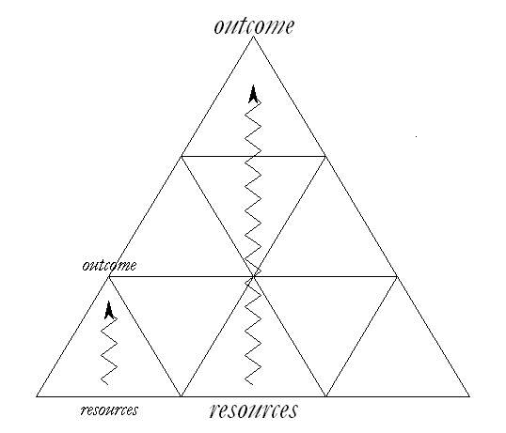
This pyramid chart offers a way to think about where the goal of your campaign can be nested within a larger mission in scope or in scale. At every level, strategy requires imagining an outcome, assessing resources available to achieve that outcome, and, in light of the context, devising a theory of change: how to turn those resources into the power needed to achieve that outcome, a theory that is enacted through tactics, timing, and targeting. In the bus boycott, planning the initial meeting required strategizing as much as figuring out how to sustain the campaign for the long haul. It is likely different people are responsible for different strategic scope at different levels of an organization or for different time periods, but good strategy is required at every level.

After agreeing upon criteria that make for a good strategic goal in your context, brainstorm again, generating as many possible goals as you can. Then evaluate them each against the criteria you’ve established.

STEP 5: WHAT TACTICS CAN THEY USE?

Remember what a “tactic” is? It’s the activity that makes your strategy real. Strategy without tactics is just a bunch of ideas. Tactics without strategy wastes resources. So the art of organizing is in the dynamic relationship between strategy and tactics, using the strategy to inform the tactics, and learning from the tactics to adapt strategy.

Your campaign will get into trouble if you use a tactic just because you happen to be familiar with it - but haven’t figured out how that tactic can actually help you achieve your goal. Similarly, if you spend all your time strategizing, without investing the time, effort, and skill to learn how to use the tactics you need skillfully, you waste your time. Strategy is a way of hypothesizing: if I do this (tactic), then this (goal) may happen. And like any hypothesis the proof is in the testing of it. Criteria for good tactics include:
- Strategic: it makes good use of your constituency’s resources to make concrete, measurable progress toward campaign goals. Saul Alinsky and Gene Sharp are excellent sources of tactical ideas.

- Strengthens your organization: it improves the capacity of your people to work together.

- Supports leadership development: It develops new skills, new understanding, and, most importantly, new leadership.

There are two ways to operate in the world—you can be reactive, as many organizations are, or you can be proactive. In order to be proactive you have to set your own campaign goals and timeline, organizing your tactics so that they build capacity and momentum over time.

STEP 6: WHAT IS THEIR TIMELINE?

The timing of a campaign is structured as an unfolding narrative or story. It begins with a foundation period (prologue), starts crisply with a kick-off (curtain goes up), builds slowly to successive peaks (act one, act two), culminates in a final peak determining the outcome (denouement), and is resolved as we celebrate the outcome (epilogue). Our efforts generate momentum not mysteriously, but as a snowball. As we accomplish each objective we generate new resources that can be applied to achieve the subsequent greater objective. Our motivation grows as each small success persuades us that the subsequent success is achievable - and our commitment grows.

A campaign timeline has clear phases, with a peak at the end of each phase—a threshold moment when we have succeed in creating a new capacity we can now put to work to achieving our next peak. For example, one phase might be a 2 month fundraising and house meeting campaign that ends in a campaign kickoff meeting or rally. Another phase might be 2 months of door-to-door contact with constituents affected by the problem you’re trying to solve, collecting a target number of petitions to deliver with a march on the Mayor at City Hall at the end, another peak. But within each phase there is a predictable cycle, which in a sense is a mini-campaign in itself: training, launch, action, more action, peak, evaluation. When organizing a peak, keep in mind a specific outcome that you want the peak to generate. For example, if you want to sign-up 50 new volunteers at an event or launch three neighborhood teams, how do you make that happen?

After each peak, your staff, volunteers and members need time to rest, learn, re-train and plan for the next phase. Often organizations say, “We don’t have time for that!” Campaigns that don’t take time to reflect, adjust and re-train end up burning through their human resources and becoming more and more reactionary over time.

Foundation
Kick-off goal
Peak goal
Strategic goal
Evaluation
& next steps
Peak goal
Capacity
(people, skills, etc.)
Time

ADDITIONAL RESOURCES FOR STRATEGIZING

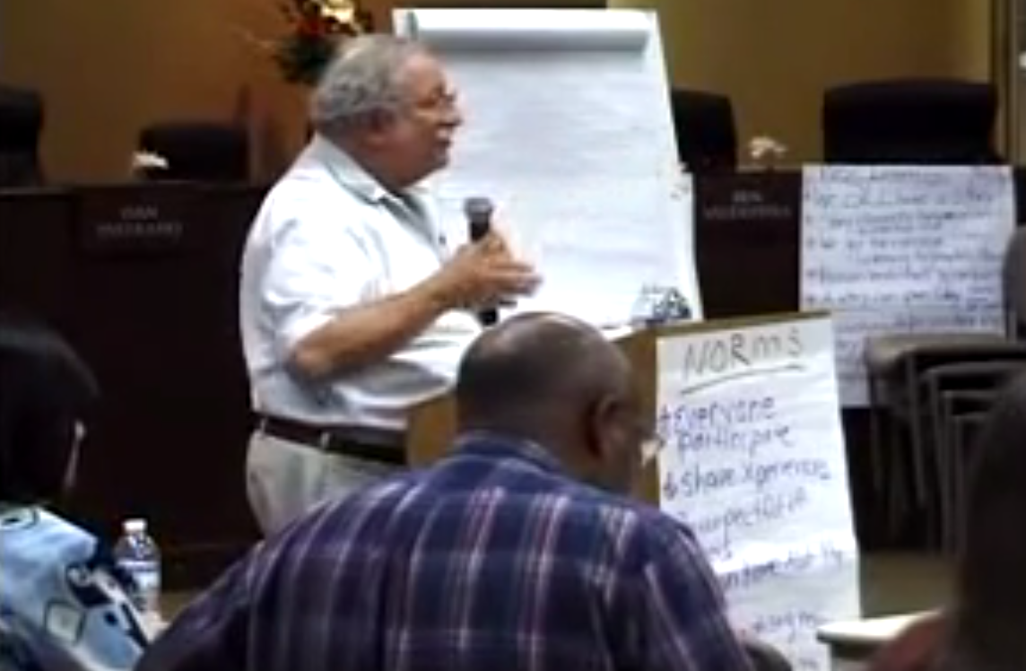
1. Video: Marshall Ganz lecture on devising shared strategy
TEAM PRACTICE SESSION: STRATEGY I
Goal
- To identify who the people are: Who is your constituency? Who are the other actors?
- To decide on a strategic goal can help you solve the problem.
- Develop a theory of change: how will you achieve your goal?

AGENDA
TOTAL TIME: 95 minutes

As a team, you will come up with a strategic goal for your team’s organizing campaign, map the actors, and develop our theory of change. Then you’ll get feedback before breaking out again for a second strategizing session.

 | - Gather your team. Choose a timekeeper and scribe. Review agenda. Review the Organizing Sentence. Refer back to the constituency and purpose sections of the shared purpose exercise. | 5 min.
 | - Get focused: Who are your people? What change do they need? What is your purpose? | 35 min.
 | - Define the field: who are the actors? | 15 min.
 | - Develop your theory of change.  - Decide upon your strategic goal. | 15 min.  10 min.

WORKSHEET:
DEVELOPING STRATEGY I: PEOPLE, POWER, CHANGE

1. REVIEW THE ORGANIZING SENTENCE (5 min.)

On one piece of flipchart paper, write out your organizing sentence. Fill in the who and what purpose sections you drafted during the shared purpose exercise.

ORGANIZING SENTENCE: We are organizing (who)___________________to pursue (why: purpose) __________________by (how: theory of change)____________________________to achieve (what: strategic goal) ________________________________ by (when: date)_______________. We will use the following tactics _________________ to achieve (outcome) ___________ by (date) _________.
*Bus boycott example: We are organizing African-Americans in Montgomery to achieve racial justice (and end institutionalized racism) by building the power we need to compel the bus company and city council to desegregate the busses for as long as it takes. We will do this by filing a law suit, mobilizing a boycott, organizing a carpool, building outside support for launching our effort by ______.

Now you will build a strategic goal based on an analysis of who your constituency is, what they want, and how they can get what they want. Follow the steps below.

- GETTING FOCUSED: WHO ARE YOUR PEOPLE? WHAT IS YOUR GOAL? (35 min.)

Step 1: With your team, fill in the table below:

PEOPLE (5 min)
Who Are My People?
(constituency)

CHANGE (30 min)
What Is Their Problem? (5 min) | How Would the World Look Different  If Their Problem Were Solved? (5 min)
Why Hasn’t Their Problem Been Solved? (10 min) | What Would It Take To Solve Their Problem? (10 min)

- WHO ARE THE ACTORS? (15 min)

Step 1: Create the map (15 min)
Draw a map-of-actors chart like the one you see below on flipchart paper. Write the names of all of the actors on sticky notes, indicating their resources and their interests. Then place them on the map of actors where you think they are most likely to be. Start with yourselves. Use what you learned from building relationships to fill this out. Brainstorm other relevant actors at local, state, and national levels by name or specific position wherever possible. Put these names on post-its and add them to the map. Be sure to include the following:

  - Who might be members of your constituency?
  - Who might be your opposition?
  - Who might be your allies (support)?
  - Who might be competitors?
  - Who might play other key roles, depending on how they are mobilized (courts, press, voters, etc.)
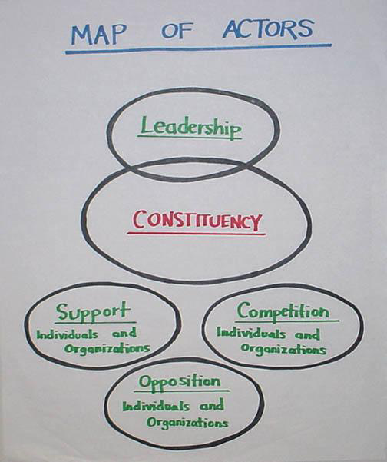

- WHERE’S THE POWER? DEVELOPING YOUR THEORY OF CHANGE (15 min)

Your theory of change is your hypothesis about how to organize your constituents’ resources to affect those who hold the resources/power to solve the problem. What would it take to get these different actors to take actions that further your strategic goal? At what point will they actually feel your constituents’ power?

Think back to your strategic goal: Who holds the resources and decision-making power needed to achieve that goal?

Fill in the corresponding table below:
POWER WITH  Start in this column. Think about the resources your people have and how they can use these resources to achieve their goal. | POWER OVER  If your people need access to the resources held by others to achieve the goal, complete the following:
1. What resources do our people hold that they can use to achieve their goal? (make a creative and specific list) | 1. What resources do our people need to access to achieve the goal? (make a specific list)
 | 2. Which actors hold those resources?
2. Why haven’t our people used these resources to achieve their goal? | 3. What resources do our people hold that these actors need?
3. How can our people use their resources in new ways that can achieve their goal? | 4. How can our people leverage what they have to get what they want from these other actors?
Write your theory of change:
If my people use their resources to do…

Then the result will be…

Because…

- DECIDE ON YOUR STRATEGIC GOAL (10 min)

Review criteria for a good strategic goal (2 min)
- Focuses effort
- Motivates participation
- Leverages resources
- Builds capacity
- Can be emulated

Decide on a Strategic Goal (8 min)

What concrete outcome will you aim to achieve that will help your constituents get what they want? First openly brainstorm and build upon each idea, then use your criteria above to evaluate them, and make a decision.
What is the goal of your campaign?

- REVIEW YOUR WORK, SUMMARIZE, VISUALIZE (10 min.)

- Review your team’s work so far in this section and discuss these questions:
  - Are we clear on our constituency?
  - Do we want to specify our goal more concretely?
  - Are we clear about our theory of change?

On two pieces of flipchart paper, write out the following:
- Write out your organizing sentence.

ORGANIZING SENTENCE: We are organizing (who)___________________to pursue (why: purpose) __________________by (how: theory of change)____________________________to achieve (what: strategic goal) ________________________________ by (when: date)_______________. We will use the following tactics ________________ to achieve (outcome) ___________ by (date) _________.
*Bus boycott example: We are organizing African-Americans in Montgomery to achieve racial justice (or end institutionalized racism) by building the power we need to compel the bus company and city council to desegregate the busses for as long as it takes. We will do this by filing a law suit, mobilizing a boycott, organizing a carpool, building outside support for launching our effort by ______.

- Draw a picture of your strategic goal. What would the world look like if you achieve it?

TEAM BREAKOUT SESSION: STRATEGY II
Goals
- To decide on the tactics that can help you achieve your strategic goal.
- To put those tactics on a campaign timeline culminating in a peak.

AGENDA
TOTAL TIME: 45 minutes

As a team, you will brainstorm tactics that will help you achieve your strategic goal, sequence your tactics into peaks on a campaign timeline, and visualize your kickoff tactic.

 | 1. Gather in your team. Nominate a timekeeper and scribe. Review agenda and clarify concepts.  2. Review your theory of change and strategic goal. Incorporate any feedback from the Strategy I debrief. | 2 min.  5 min.
 | 3. What tactics can help you achieve the goal? On what timeline? Use the following worksheet to help you strategize.  4. Brainstorm and visualize your kickoff tactics using the worksheet.  * | 20 min  15 min.

WORKSHEET:
DEVELOPING STRATEGY II: TACTICS AND TIMELINE

1. TACTICS & CAMPAIGN TIMELINE (Total: 20 min)

Step 1: Brainstorm Tactics (10 min)
As a team, brainstorm as many tactics as you can in 10 minutes on flipchart paper. Your tactics should be based on your theory of change. How will you organize your constituency’s resources to create the change they want? Good tactics are based in the culture and experience of your people and reflect your values.
Then decide on the top three, using the following criteria: do they make good use of your resources? Do they build capacity? Do they help you to achieve your goal?
Step 2: Sequence Tactics into Peaks (10 min)
Strategize Backwards. How will you organize your tactics over time to achieve your strategic goal?

For each tactic, determine a peak goal—what would it look like to achieve it? A peak is typically an event or action with your constituency that shows all the capacity that’s been generated since the last peak. Starting at your strategic goal, work backwards to sequence your peaks on a campaign timeline (see example below).
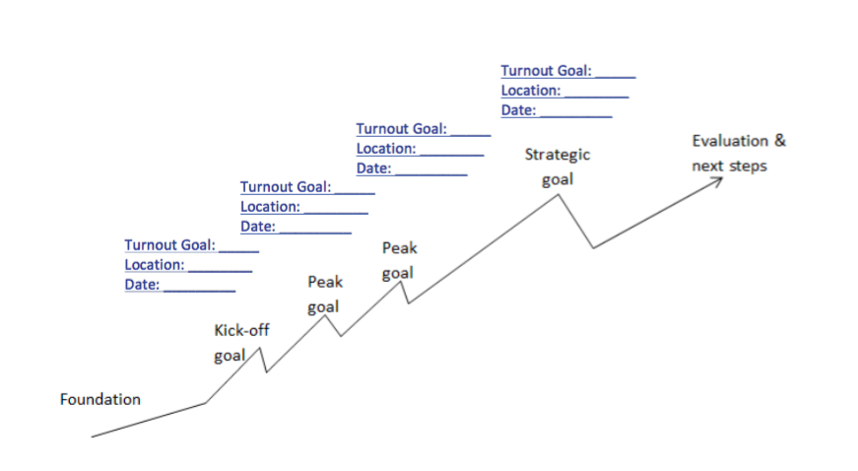
Ensure that each peak builds on what came before so that you are gaining power and capacity over time, culminating in your strategic goal. What outcome do you want from each peak (for example, how many new people sign up or how many people participate in a march)?
2. KICK-OFF TACTIC (Total: 15 min)
Step 1: Brainstorm Kickoff Tactics (5 min)
Strategize Forward. Now focus on your first peak: your campaign kickoff. What measurable outcome will you try to achieve with this first kickoff? How will the kickoff be motivational for your constituency? How will it reveal to your community its own resources, courage and solidarity?
Brainstorm as many tactics for your kickoff as you can in 10 minutes on a flipchart paper. Try to use “Yes, And!” strategizing, rather than “No, But!” Build on each other’s ideas. Then use your decision-making process (from yesterday’s team exercise) to decide which tactic you will organize as a team.
Step 2: Visualize (10 min)
A. As a team, draw a picture of your kick-off tactic. What will it look like? When will it take place? Where? Who will be involved? How many? What will they be doing? What will they be wearing? What will you be doing? When?
Our Kickoff Tactic Visualization:

B. Make a list of the things that need to get done between now and then in order to effectively organize your kick-off tactic:

MOBILIZING SHARED COMMITMENT:
ACTION

How do we inspire others to join us in taking action?

SHARED MEASURABLE ACTION
What is action?
Goals for this section:

Learn to commit people to joining you in action.

Learn to design action that will motivate people to recommit to do more.

Action consists of mobilizing and deploying constituency resources in ways that can create the power needed to win.

First, effective action produces results that contribute to accomplishing your goals.

Second, effective action strengthens your organization and attracts and engages new people; it increases our community’s capacity to effect change in the future.

Third, effective action contributes to the growth of individuals involved in the campaign; it develops leadership.

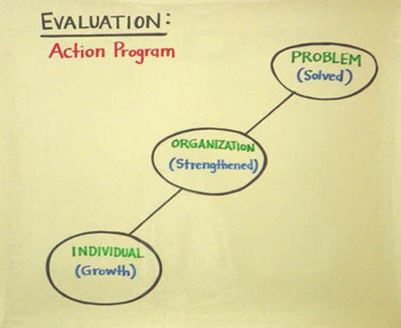

How can we engage in effective action?

Effective action requires commitment and motivation. 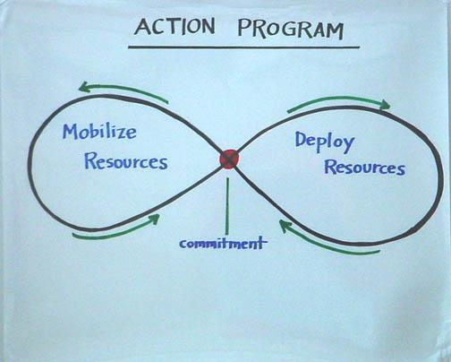

How do we get clear commitments?

First, we must mobilize others to make explicit commitments in order to achieve specific, measurable outcomes.

When we commit others to action, we are giving them an opportunity to make a meaningful contribution to a cause they care about. So why don’t we always just ask? Sometimes, we worry about burdening others, or we worry that they will say no and we’ll feel rejected, or maybe they’ll say yes and then we’ll have to commit ourselves!

When we ask others to join us, it is critical that we use clear, concise language. Sometimes we may try to minimize the commitment, making it seem smaller or less important than it really is. But respecting others means being very transparent about the work ahead, about the support they’ll receive, and giving them a choice of whether or not to commit.

Mobilizing effective commitments requires four steps:

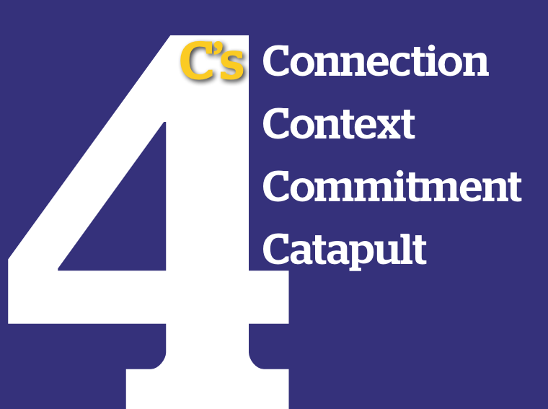
- Connect: Make the “ask” as specific as you can to the person whom you are trying to mobilize. Identify yourself, why you’re doing what you’re doing, and let them know why you’re asking them to help. This can be done with few words.

- Context: Explain why the action you are asking them to take is urgent. Be specific about the challenge and the hope.

- Commitment: Explicitly ask the other person if you can count on them to engage in action with you. Be very specific about the date, time, and place.
- “Can we count on you to join us in _____________ ?”
- “Will you join me in doing ____________ ?”

LISTEN CAREFULLY. Is the answer:
“Yes! Definitely!” (Great! Confirm the details)
“Maybe . . .” (Ask what questions they have and how you can follow up.)
“No, I’m sorry.” (Ask why? Give them your contact info in case they change
their mind.)

- Catapult: If someone says “yes” then give them the respect of having real work and real responsibility at your action and a real plan to get there. Ask:
- Can you bring something to the event (i.e. food, posters, etc.)?
- Can you commit to bringing 2 friends with you?
- How do you plan on getting to the event? (people with plans are much more likely to attend!)
How do we confirm and follow up on commitments?

In our Introduction to Organizing we gave the following definition of leadership: Taking responsibility for enabling others to achieve purpose in the face of uncertainty. Taking responsibility means that we can’t just get a commitment to action, pocket it like change, and walk away. We have the responsibility to follow up and do everything it takes to support others in joining us. Most important are “reminder calls” and the closer to the event, the more important and effective the reminder call will be.

- Recruit others and get a specific commitment to action.

1.
Recruit

2. Confirm (3X)

3.
ACTION!

4.
Evaluate & Celebrate

5.
Thank you!

- Confirm the commitment a few days out. Check in and see if the people who committed need a ride, can invite others, or can take responsibility for part of the action. Confirm the day before the action. Provide full details on the place, time and purpose of the action, including any updates on the agenda or attendees. Confirm one more time 30-60 minutes before the action—the period when we’re all most likely to find something more urgent to do. Convey how excited you are to have others join you in action.
- ACTION! Lead a motivational action that respects others’ time, but also provides full training, opportunities for relationship building, and purposeful, measurable action.
- Evaluate & celebrate the action together. Tally up all measurable outcomes so that everyone can see that they’re part of a bigger whole. Debrief in detail what worked and what should change next time. Then celebrate! Who wants to spend their free time without having fun?! Generate routines for how people in your organization celebrate together, perhaps with food, music or a round of stories from the day.
- Thank everyone the next day for their participation in action. Tell them specifically what impact the action had in the campaign. Ask for their input on what worked and what should be changed next time.
- Move participants to the next level of leadership where they can help you and your team plan more actions in their city or neighborhood.
How do we design motivational action?

For action to engage others in ways that expands—rather than depletes—our resources, we need to design action mindfully. If people feel that what they are doing is insignificant, or that they are being used, or that they must do boring and meaningless work, then they are unlikely to take initiative, solve problems or recommit.

Task Characteristics Outcomes
Task Significance (TS) (“The task really matters”)
Motivation
Task Identity (TI) (“My contribution is clear”)
Problem Solving
Skill Variety (SV) (“Involves my head, heart and hands”)
Commitment
Choice (C) (“I can choose how I do the work”)

Feedback (FB) (“I see how I’m doing as I do it”)

How does motivational task design work?

Outcomes: When a task is well designed, people who participate will feel more motivated, take initiative in solving problems, and make a deeper commitment to the work.

Design: Creating the experience to achieve these outcomes requires attention to these five elements of design:

- Task Significance (TS) – Experiencing the impact of the work on the world.
- Task Identity (TI) – Recognition of your “ownership” of a clear piece of the work.
- Skill Variety (SV) – Engagement of a variety of skills including heart, hands, and brain.
- Choice (C) – Having the space to make competent choices about how to do the work.
- Feedback (FB) – Results are visible to the person performing the task, even as they perform.

Designing Motivational Tasks

Using the checklist below, we can evaluate tasks to determine how motivational they are, redesign them to make them more motivational, and construct them so as to create a leadership ladder, opportunity for people to earn greater responsibilities.

Task Design Ladder

Level 1 Level 2 Level 3
TI
TS
SV

A

F

Getting into action now

The action we’ll engage in is to make a clear ask of your peers to support you in a specific, measurable action, and making phone calls to ask others to join you for your kick-off tactic!

ADDITIONAL RESOURCES FOR COLLECTIVE ACTION

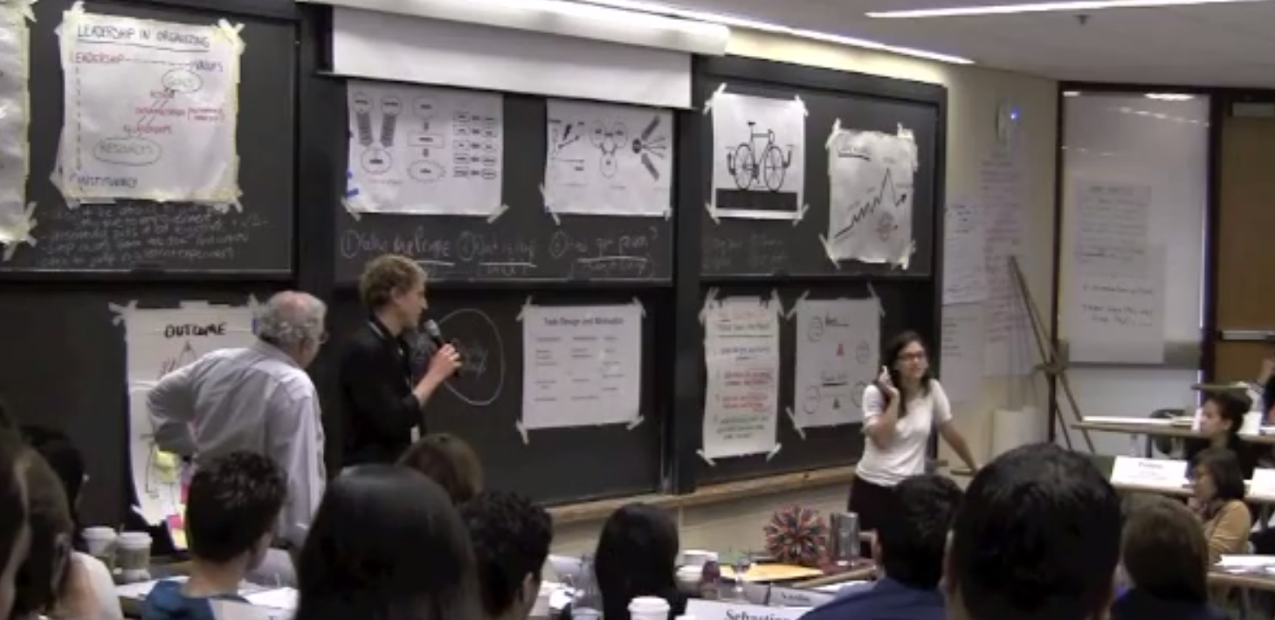
1. Video: Marshall Ganz lecture with model example of asking for commitment to action
TEAM PRACTICE SESSION:
ACTION

Goals:
- Practice the core organizing skill of recruiting others to make a real commitment to translate their values into action.

AGENDA
TOTAL TIME: 45 min.
1. Gather with your team. Choose a timekeeper. Review the agenda. 2 min.
2. As a team, decide on your goal for this exercise: how many total commitments will 3 min.
you need to get for your next “peak” action? How many “asks” will you have to make?
Write it on the worksheet that follows.
3. As individuals, take time to note the key questions you will ask to get a conversation 7 min.
going, the key stories you will share to bring yourself to the table, and the specific “ask”
you will make. This is not a “script” that you will read, but rather a guide for a
meaningful conversation. Use the worksheet that follows. You may also practice leading the conversation with others in your small group.
4. Role-play. Take turns practicing making a “hard ask” with your team members. Each team member has up to 4 minutes to try and recruit another team member to your upcoming action. Team members who are role playing being recruited should not make it too easy. While Partner A is attempting to recruit Partner B everyone else should observe, pay attention to what works well and what could have been done better, then give constructive feedback and coaching to the person who was recruiting. After feedback, switch so that everyone gets at least one turn practicing getting a commitment.
Round 1 (8 mins per round):
Partner A recruits Partner B (4 min)
Feedback from observing team members (4 min)
Take turns until everyone has had a chance to practice getting commitments. 40 min.
5. Start recruiting! Each team member spend the next hour making calls to your constituency asking for commitments. Each individual should use the worksheet that follows to track how many “asks” you’ve made, how many commitments, and how many catapults you’ve obtained. 60 min.
6. Debrief with your team. Tally up your individual results and your whole team’s totals. Who reached the most people? Who had the highest rate of commitments? What worked and what were the challenges for each person? What are your key takeaways? 15 min.

WORKSHEET:
DEVELOPING THE SKILL OF ENGAGING REAL COMMITMENT

Step 1: Decide on your team’s goals for this exercise and record it in the table below (3 min.)

TEAM NAME | TEAM GOAL: How many total commitments do we need? | How many people will we make “asks” to in order to reach our goal?

Step 2: Role Play - Prepare for Your Meaningful Commitment Conversation (40 min.)

Using the story work you’ve done to help you write your recruitment call script. The keys here are that you ask questions to understand the motivations of the person you’re engaging, that your story include something about you, and why you're motivated to act; you tell a little bit about who your group is, and why they've come together now to work on this; and present the choice that your listener has to make – join us at our upcoming action.

Don’t worry about getting it exactly right; your conversations will each be different anyway – they should be conversational and respond to your listener, not overly scripted or formal. But here is a good list of sample talking points that you can use to orient yourself.

YOUR “SCRIPT”:

Hi, my name is ___________________, and I’m at _______ today. I got your name from ________ who said you would be a great candidate to help us launch a local campaign next month to fight for quality public schools for our kids.

Some things to keep in mind as you prepare:
- CONNECTION: Let the person know who you are, why you care about this issue, and ask how they have been affected (drawing on your story of self and story of us).

Key questions to ask to get conversation going (remember to LISTEN):

- Have you heard about the movement we’re building at ______? If not, let me tell you about it…
- Tell them about your experience here, the people, and the _________ campaign being launched
- How did you get started organizing? In what context? (on/off campus/in your community)
- How are you already involved with working on public education issues?

Make note of the key parts from your story work that reveal your motivation to do this work:

2) CONTEXT: Explain what you and your team are planning. Provide details about who your group is, the exact challenges that move you to action right now, the real hope, and a strategic choice.

3) COMMITMENT: Getting commitment: Will you join me in launching this campaign to do __________ on _________date? What do you think?

- WAIT for them to think and respond.
- Confirm the DATE, TIME, LOCATION. “Can I count on you to be there?”
- “Who else can you suggest I contact? Or would you like to help me recruit?”

4) CATAPULT: Next Steps: Thank them for their time, find a time that you can follow up in a few days, explain the recruitment process going forward.

If they said “yes” to joining you, give them the chance to lead. What roles are empty on your leadership team? What work needs to get done to prepare for your event? How could they help you?

Step 3: Start Recruiting! (60 min)
On a shared spreadsheet, have each member make recruitment phone calls. Keep a tally of how many “asks” each team member makes and how many commitments you actually get.
Individual team members’ names: | How many “asks” did you make? | How many commitments did you get? | How many catapults did you get?
1. YOUR NAME:
2. Team member 2:
3. Team member 3:
4. Team member 4:
5. Team member 5:

WHOLE TEAM TOTALS

Step 4: Team Report Back & Debrief (5 min)

When you gather to debrief, fill in the rest of the table, above, by having each member of your team report back the number of “asks” made, commitments received, and catapults obtained. Tally up the totals for your whole team and see how it stacks up with your original goal.

PUTTING IT ALL TOGETHER:

STORY OF NOW AND
LINKING SELF/US/NOW

How do we bring our values, strategy and action together?

INTRODUCTION TO STORY OF NOW

The Story of Now describes an urgent choice faced by the “us” whom you hope to mobilize to act: a challenging vision of what will happen if it does not act, a hopeful vision of what could be if it does act, and a call to commit to the action required. In this way a story of now makes the bridge from story – why we should act – to strategy – how we can act effectively.
Goals for this session:

To learn how story can move us to action

To learn how to bridge from strategy into action

Each participant practices telling a story of now and gets feedback on his/her story

Now we know why you’ve been called to your mission. We also know who the “us” is that you will call on to join you in that mission. A story of now articulates the urgent choice faced by that “us” that requires action: a challenging vision of what will happen if they do not act, a hopeful vision of what could be if they do act, and a call to choose commitment to the action required. The “character” in a story of now is you, the people in the room with you, and the broader community whom you hope to engage in action.

In Washington DC, August 23, 1963, Dr. Martin Luther King told a story of what he called the “fierce urgency of now.” Although we all recall his vision of what America could be, his dream, we often forget that action was urgent because of the “nightmare” of racial oppression, the result of white America’s failure to make good on its “promissory note” to African Americans. This debt, he argued, could no longer be postponed. If we did not act now, we could never realize the dream.

In a story of now, story and strategy overlap because a key element in hope is a strategy – a credible vision of how to get from here to there. And a key element in strategy is a source of hope – a sense of possibility. The “choice” we offer must be more than “we must all choose to be better people” or “choose to do any one of this list of 53 things” (which makes each of them trivial) or “go to x website and click”. A meaningful choice requires action we can take now, action we can take together, and an outcome we could achieve.

The “character” in a story of now is you, the people in the room with you, and the broader community whom you hope to engage in action.

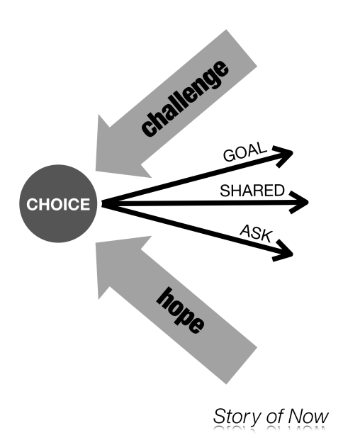
The Elements of a Story of Now

- The Challenge – The challenge we are facing now (made real through stories, not just statistics)

- The Outcome‐‐A plausible pathway to action, a sense of the “possible”, of what “could be” if we act now.

- The Choice‐‐A choice to commit to that pathway to action that each person in your audience can make right now.

Why It Matters

The choice we’re called on to make is to act now. Leaders who only describe problems, but fail to identify a way to act altogether to address the problem, aren’t very good leaders. If you are called to address a real challenge, a challenge so urgent you have motivated us to face it as well, then you also have a responsibility to invite us to join you in action that has some chance of success. A “story of now” is not simply a call to make a choice to act – it is a call to “hopeful” action.

VIDEO REVIEW:
GANDHI

We'll be watching a video of Gandhi telling a story of now. While you watch it, think about the elements of the Story of Now that make up his call to action.
Model video link: Gandhi movie clip

CHALLENGE | OUTCOME | CHOICE
How does he confront his audience with a real, urgent challenge? What images does he create? What is the source of anger? | Where does he locate the source of hope? Could the community do what he asks? Could it work if they act together? | What does he ask the community to do? What makes it meaningful?

- Why does Gandhi begin as he does?
- What details, images, moments do these stories bring alive?
- What values does he draw upon and challenge his audience to live up?

PUTTING IT ALL TOGETHER: LINKING PUBLIC NARRATIVE

If I am not for myself, who will be for me?
When I am only for myself, what am I?
If not now, when? —Hillel, 1st century Jerusalem sage
Pirke Avo
As Rabbi Hillel’s powerful words suggest, to stand for yourself is the first step, but insufficient on its own. You must also find or create a community to stand with, and that community must begin acting now. To combine the stories of self, us and now, you have to find the link between why you are called to this mission, why we as a community are called to this mission, and what our mission calls on us to do now.

That linking may require you to continually rethink the stories of self, us, and now that you are working on.

Storytelling is a dynamic, non-linear process.

Each time you tell your story you will adapt it – to make yourself clearer, to adjust to a different audience, to locate yourself in a different context. As you develop a story of us, you may find you want to alter your story of self, especially as you begin to see the relationship between the two more clearly. Similarly, as you develop a story of now, you may find it affects what went before. And, as you go back to reconsider what went before, you may find it alters your story of now.

Storytelling takes practice.

Our goal is not to leave with a final “script” of your public narrative that you will use over and over again. The goal is to help you learn a process by which you can generate your narrative over and over and over again, when, where, and how you need to in order to motivate yourself and others to specific, strategic action.

MODEL VIDEO REVIEW:
BARRACK OBAMA

We'll be watching Barrack Obama’s keynote speech at the 2004 Democratic National Convention. While you watch it, think about the elements of SELF – US – NOW that you hear in his story. You may also go back and take another look at Jame’s Croft’s Public Narrative which was included earlier in this manual.
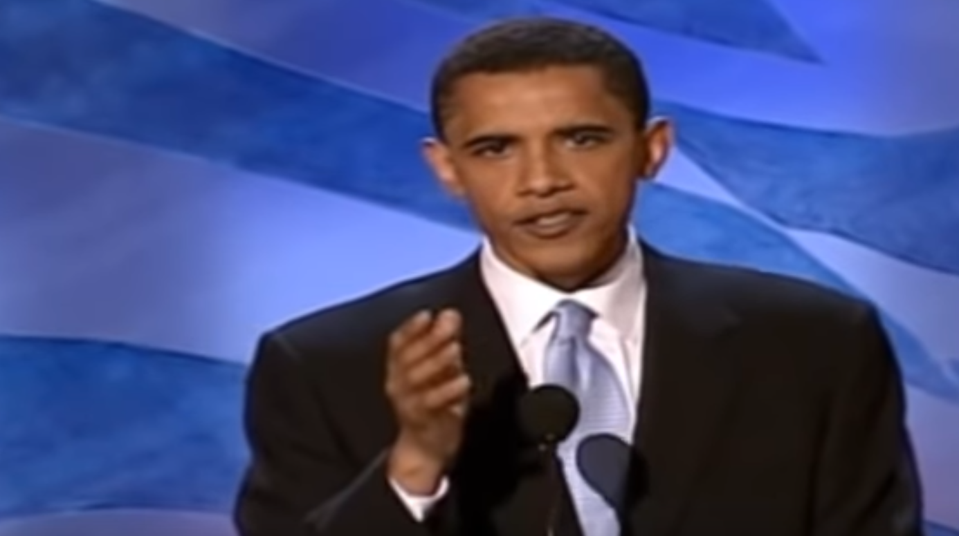
Video link: Barrack Obama 2004 keynote speech

SELF | US | NOW
What experiences shaped his values? Whose choices were they? Why are they stories? | Who is the “us” to whom he appeals? What moments of choice does he recall? What are the values? | What challenges to those values does he describe? What’s the source of hope? In what action does he ask us to join?

- Why does Obama begin as he does? When does he move from Self to Us to Now?

- What challenge, choice, and outcome are at the core of each story he tells?

- What details, images, moments do these stories bring alive?
- What values do these stories communicate?

TEAM BREAKOUT SESSION:
LINK SELF / US / NOW & ASK FOR COMMITMENT

GOALS
- Learn how integrate your stories of self / us / now into a public narrative
- Ask for commitments by articulating a specific choice point for others to make

NOTE: It’s more than an “ask.” It’s a choice about whether someone’s going to stay on the sidelines or dive in and act on their values. It’s an opportunity for them to join with you.

AGENDA
TOTAL TIME: 40 min.
 | Gather in your team. Nominate one person to be a timekeeper. | 2 min.
 | Take some time as individuals to silently develop your “Public Narrative.” Link your story of now with a story of self and story of us. Use the worksheet that follows. | 5 min.
 | As a team, go around your group to practice your full public narrative.  - Each person has 3 minutes to tell his/her public narrative, and with 2 minutes for feedback.  - Be sure that you end by asking for a clear commitment that is rooted in your team’s project and your strategy.  ** NOTE: You have 3 minutes to tell your story. Stick to this limit. Make sure the timekeeper cuts you off. It encourages focus and ensures everyone has a chance. | 25 min.
4. | As a team, go around your group to do a round of appreciations. Each person has up to 1 minute to appreciate the teammate sitting to her or his left for a contribution they have made or a moment you have shared. | 5 min.

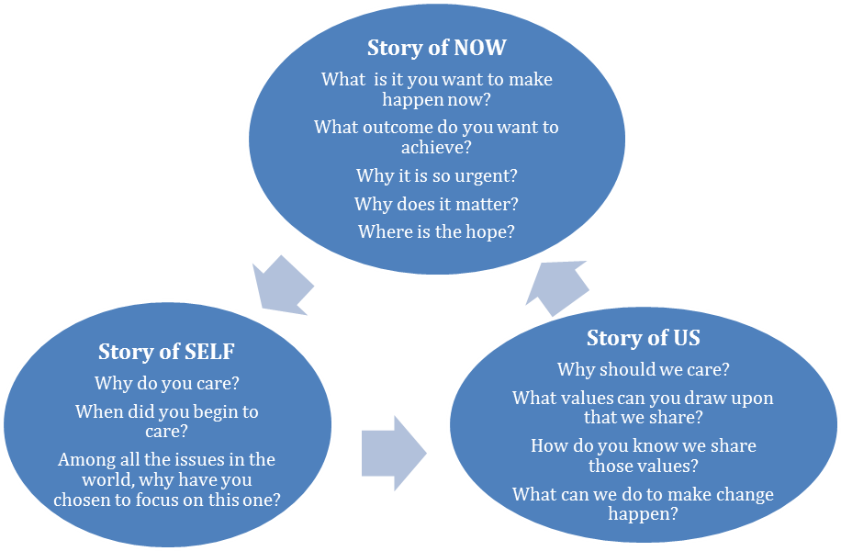
Start here

WORKSHEET:
LINK SELF / US / NOW

Linking Chart: As you begin developing your linked public narrative, remember that your values are what link the different pieces of your story together, so make sure you communicate clear and consistent values throughout. Also be sure to include self, us and now as well as challenge, choice, and outcome. Once you’ve crafted your linked narrative, you should be able to mark an “X” in each box below.
 | Challenge | Choice | Outcome
Self
Us
Now
Clear & consistent values?
Are values present throughout?

WORKSHEET:
LINK SELF / US / NOW

Story of Now
What stories communicate the urgent challenges that your community faces?

What stories can offer your community a sense of hope?

Story of Self
What stories can you tell about the experiences and/or values that call you to take leadership within education? Think of particular challenges you faced, choices you made, and the outcomes in those experiences.

Story of Us
What stories highlight the shared values and experiences of the people to whom you’re speaking? Think of specific collective challenges you faced as a community, the collective choices you made, and the outcomes of those experiences.

What specific “ask” are you making to others to join you in meaningful action?

______________________________________________________________________________

COACHING TIPS:
PUBLIC NARRATIVE

DON’T simply offer vague “feel good” comments. (“That was a really great story!”)
DO coach each other on the following points:

- THE CHALLENGE: What is the specific challenge we face now? Did the storyteller paint a vivid and urgent picture of it? What details might make it even more vivid and urgent?
“The challenge wasn’t urgent enough. Why not mention ________?”

- THE OUTCOME: What is the specific outcome if we act together? Is there a clear and hopeful vision of how the future can be different if we act now?
“The outcome could be even more hopeful if you described _______.”

- THE CHOICE: Is there a clear choice that we are being asked to make in response to the challenge? How did the choice make you feel? (Hopeful?)
“What exactly are you asking us to do? When should we do it? Where?”

- VALUES: What values do you share with the storyteller? Does the story of now appeal to those values?
“Instead of telling us to care, it would be more effective if you showed us the choice to be made by illustrating the way in which you value .”

- DETAILS: Were there sections of the story that had especially vivid details or images (e.g. sights, sounds, smells, or emotions)?
“The image of ________ really helped me feel what you were feeling.”
“Try telling more details about _______ so we can relate to this shared experience.”

- INTERWEAVING SELF, US AND NOW: Did the story of self and the story of us relate to the story of now? If so, what was the common thread? If not, what thread could the storyteller use to rethink the connections between self, us and now?

Record Feedback/Comments from Your Team Members Here:

Coaching Your Team's Public Narrative
As you hear each other's public narratives, keeping track of the details of each person’s story will help you to provide feedback and remember details about people on your team later. Use the grid below to track your team's public narratives.
NAME | VALUES | SELF | US | NOW
Appendix
More On Coaching As A Leadership Practice

How do I prioritize who to coach in organizing?

When you have several individuals or teams to coach, where do you start? Where do you put most of your energy to get the best outcomes?

Invest your first coaching effort in those who are doing the best work. This seems counterintuitive, but the purpose of coaching is not just to fix problems – it’s to help people achieve excellent outcomes.

Coaching your most innovative, productive people first maximizes their productivity, and preps you to coach others by giving you a detailed understanding of what excellent work looks like in practice. And if your best folks get even better, they can help you coach and support their peers.
Next, coach those who are showing promise. With what you’ve learned from the strongest groups, move on to those who are doing good work and help them make the leap to great. Utilize the tips in the 5 Step Coaching Process section for choosing interventions to help you tailor your coaching.

Finally, focus on the individuals and teams who are struggling. Watch these folks in action before jumping to conclusions. Are they struggling because of contextual factors, like a lack of resources, or because of inadequate skill or effort? Try investing a little more (resources, training or support), and see if outcomes improve. If so, great, keep coaching! If not, then assess whether this person is in the right role. Whether you’re coaching staff or volunteers, making sure the right people are in the right roles based on their skill and passion is a basic form of respect. While it’s painful for all involved in the short term, helping someone move on from a role that’s not well suited for them will only help everyone in the long term.

Be careful to set boundaries on your coaching with those who are struggling the most so that you continue to spend time and energy to keep your excellent folks going strong, and your good folks getting better.

How do I coach organizers to learn from failure?

In her book, Mindset, Carol Dweck argues that we all tend toward one of two mindsets: fixed or growth. The fixed mindset claims we’re born with our basic qualities, like intelligence or talent, which can’t improve or change (so why try?). Ever heard someone give a poor presentation, then say, “I’m not a good public speaker”? That’s a fixed mindset.
The growth mindset asserts that we can develop our abilities through dedication and hard work. Our job as coaches is to cultivate a growth mindset in those we’re coaching. That requires learning to look directly at failure and understand it so we can improve.

Here are some tips for learning from failure, while striving for success:

Create a culture of debriefing. Before work begins, schedule time to debrief into every step. Make time after every event or project to evaluate what worked, what didn’t, and articulate key learning’s together. Require short written reflection on major projects, especially those that fall short.

Differentiate between actions and context. It’s easy to hold someone responsible for every outcome. But success and failure are a combination of individual actions and situational context. As you develop a learning relationship with the person you’re coaching, pay close attention to the details. When does one action lead to success? Under what conditions does the same action lead to failure? Success requires constantly evaluating the context and adapting our behavior to maximize good outcomes.

Interpret what happened. Coach the person you’re working with to interpret failure with clear eyes. Hiding failure or pretending it was success doesn’t fool anyone. Show those you coach that interpreting failure is an integral part of winning. Check out Barack Obama’s speech after his New Hampshire primary loss for a great example of interpreting failure in a way that stays focused on driving for success (http://www.youtube.com/watch?v=Fe751kMBwms).

Get back out there! Who wants to wallow in failure? Encourage those you coach to get out there and try again!

Pirke Avot (Wisdom of the Fathers)
Marshall Ganz, “Leading Change: Leadership, Organization and Social Movements”, Chapter 19,

